

AMATEUR RADIO

BASIC QUALIFICATION MANUAL

***8th Edition***

*The goal of this guide is to provide the reader with a concise, yet complete, courseware which will provide the reader with the required level of knowledge for the Amateur Radio Basic Qualification certificate. The 8th Edition, like its predecessors, is the only Canadian training manual to include a detailed summary and interpretation of the rules and regulations pertaining to the Amateur Radio Service. In addition to the applicable theory, the section covering operating practices has been expanded to assist the new ham in obtaining confidence on the air. Innovation, Science and Economic Development Canada has recently released new exams containing a greater number of block diagrams. The 8th Edition provides complete coverage of all block diagrams found in the latest exams. This edition also excludes Innovation, Science and Economic Development Canada’s Question Bank, which are now available online. We welcome you to the world of Amateur Radio and wish you the best of luck.*

***Acknowledgements***

*This study guide resulted from the dedication of several amateur radio enthusiasts.*

*Original authors: Sidney Kemp, Cam Finnigan (VE7ACW), Niall Parker (VE7HEX), and Doug Wirsz (VE7VZ).*

*Editors: Ken Nanson (VE7KSN), Dave Koyanagi (VE7CNV), Matthew Laird (VE7MLD), Dale Jackaman (VE7GL), Kendall Lo (VA7CRV), Kazuo Itoga (VA7ITO) and Andrew Juren (VA7AJJ)*

*Copy Editor: Helen Ho*

*Graphics, page layout and design: Stephen Chan (VE7HAA), Dale Jackaman (VE7GL), Dave Martindale (VE7YDM), and Helen Ho*

*Additional contributions: Dean Lai-How (VE7FVH), Dimitri Bouras (VE7HDB), Ken Nanson (VE7KSN), and Dave Cameron (VE7LTD)*

*Fifth Edition: Johnty Wang (VA7MEH)*

*Sixth Edition: Dustin Shargool (VE7VBU)*

*Seventh Edition: Daniel Hall (VA7DHH)*

*Eighth Edition: Kosta Arvanitis (VE7KCY), David Tse (VE7MDT), John Bell (VA7JBE)*

**Copyright © 1991, 2003, 2012, 2014, 2020 UBC Amateur Radio Society.**

*Permission is granted to copy, distribute and/or modify this document under the terms of the GNU Free Documentation License, Version 1.3 or any later version published by the Free Software Foundation; with no Invariant Sections, no Front-Cover Texts, and no Back-Cover Texts. A copy of the license is available at* <http://gnu.org> *in the section entitled "GNU Free Documentation License".*

*Proceeds from the sale of this book will go to the:*

*University of British Columbia Amateur Radio Society*

*Box 7, Student Union Building U.B.C.,*

*Vancouver, B.C.*

*Canada V6T 1Z1*

*E-mail:* [*ve7ubc@gmail.com*](mailto:ve7ubc@gmail.com)

*Web Site:* [*http://www.ars.ams.ubc.ca*](http://www.ars.ams.ubc.ca)

***First edition January 1991***

*Second edition November 1991*

*Third edition January 1994*

*Fourth edition April 1998*

*Fifth edition January 2003*

*Fifth edition reprint December 2012*

*Sixth edition May 2014*

*Seventh edition October 2014*

*Eighth edition April 2020*

1 Rules and Regulations Affecting the Amateur Radio Service 1

1.1 Introduction 1

1.2 Radiocommunication Act 1

1.2.1 Licensing Requirement (S-4 and S-11 Regulations) 1

1.2.2 Sanctions (S-10) 2

1.3 General Radio Regulations 2

1.3.1 Presentation of Certificate, Change of Address 2

1.3.2 Compliance with ITC (ITU) (S-10) 3

1.3.3 Obscene Language (S-25) 3

1.3.4 Remuneration 3

1.3.5 Confidentiality (S-9 Act and S-32 Regulations) 3

1.4 Radio Regulations Pertaining to the Amateur Radio Service 4

1.4.1 Frequencies (S-51) 4

1.4.2 Station Identification (S-57) 5

1.4.3 Communication Content (S-47) 5

1.4.4 Bandwidth (S-53) 6

1.4.5 Power (S-58) 6

1.4.6 Interference (S-5 Act and S-25, S-56 Regulations) 6

1.4.7 Measurements (S-61) 7

1.4.8 Restrictions on the Number of Amateur Radio Stations (S-45) 7

1.4.9 Equivalency of Certificates (S-44 Regulations) 7

1.4.10 Emergency Communications (S-50 Regulations) 8

1.4.11 Operation of Amateur Stations 8

1.4.12 ITU Regions 9

1.4.13 Miscellaneous 9

1.4.14 Q Signals 9

1.5 Operating Procedures 11

1.5.1 Emergency Communications 11

1.5.2 Call Signs 12

2 Station Assembly 12

2.1 Introduction 12

2.2 Station Components 12

2.2.1 Transceiver 12

2.2.2 Microphones 12

2.2.3 Low Pass Filter 13

2.2.4 Standing Wave Meters 13

2.2.5 Antenna Switches 13

2.2.6 Antenna 13

2.2.7 Antenna Tuner 14

2.2.8 Dummy Load 14

2.2.9 Frequency Counter 14

2.2.10 Ammeter 14

2.2.11 Voltmeter 14

2.2.12 Oscilloscope 14

2.3 Station Safety 15

3 Basic Electronics 16

3.1 Fundamental Concepts 16

3.1.1 Conductors and Insulators 16

3.1.2 Electromotive Force (E) and Power (P) 16

3.1.3 Frequency 16

3.1.4 Alternating Current (AC) / Direct Current (DC) 17

3.1.5 Resistance and Impedance 17

3.2 Ohm's Law 18

3.3 Electronic Components 20

3.3.1 Resistors 20

3.3.2 Capacitors 21

3.3.3 Inductors (chokes) 22

3.3.4 Transformers 22

3.3.5 Vacuum Tubes 23

3.3.6 Semiconductors 24

3.3.7 Diodes 24

3.3.8 Transistors 24

3.3.9 Integrated Circuits 25

3.3.10 Batteries 25

3.4 Power Supplies 26

3.5 Transmitters 27

3.5.1 Introduction 27

3.6 Continuous Wave (CW) 28

3.6.1 Amplitude Modulation (AM) 29

3.6.2 Single Sideband (SSB) 30

3.6.3 Frequency Modulation (FM) 31

3.6.4 Digital Modes 32

3.6.5 Power Amplifiers 34

3.6.6 Miscellaneous 35

3.7 Receivers 35

3.7.1 CW and SSB Receivers 36

3.7.2 FM Receivers 37

3.7.3 Filters 38

3.8 Transceivers 38

3.9 Repeaters 39

4 Interference and Suppression 39

4.1 Introduction 39

4.2 Filters 39

4.2.1 Low Pass Filters 39

4.2.2 High Pass Filters 40

4.2.3 Band Pass and Band Reject Filters 40

4.3 Types of Interference 40

4.3.1 Front End Overload 40

4.3.2 Audio Rectification 40

4.3.3 Harmonics 41

4.3.4 Parasitic Oscillations 41

4.3.5 Cross-Modulation 42

4.3.6 Spurious Emissions 42

5 Propagation and Antenna Systems 42

5.1 Waves and Propagation 42

5.1.1 Transmission propagation 43

5.1.2 The Sun and the Ionosphere 43

5.1.3 Ionospheric Layers 44

5.1.4 Absorption 44

5.1.5 Attenuation 45

5.1.6 Fading 45

5.1.7 Other Atmospheric Effects 45

5.1.8 Skip Zone 46

5.2 Antennas 46

5.2.1 General Description 46

5.2.2 Resonant frequency 47

5.2.3 Dipoles 47

5.2.4 Vertical Antennas 49

5.2.5 Yagi antennas 50

5.2.6 Quads and Loops 51

5.2.7 Antenna Measurements 52

5.2.8 Dummy Loads 52

5.2.9 Antenna Orientation 53

5.2.10 Antenna Structures 53

5.3 Transmission Lines 53

5.3.1 Parallel conductor 54

5.3.2 Coaxial Cable 54

5.3.3 Baluns 55

5.4 Antenna Safety 55

6 Operations and Procedures 56

6.1 Introduction 56

6.2 Basic Operation and Communication 56

6.2.1 Making Contacts 56

6.2.2 Making contacts with Morse Code 57

6.2.3 Transmit Power and Signal Reports 57

6.2.4 Simplex and Duplex Communication 58

6.2.5 Upper and Lower Sideband Transmission 58

6.2.6 Communication Nets 58

6.3 Emergency Operation 58

6.4 Repeaters 58

6.5 Band Plan 59

6.6 Standard Phonetic Alphabet 60

# Rules and Regulations Affecting the Amateur Radio Service

## Introduction

The Amateur Radio Service is governed by three pieces of legislation:

* Radiocommunication Act
* Radiocommunication Regulations
* International Telecommunications Union Radio Regulations

Extracts from these acts and regulations have been summarized by Innovation, Science and Economic Development Canada in RIC-1, RBR-3, RBR-4 and RIC-9.

Acts differ from regulations. Usually the acts contain general information, while the regulations are more precise and detailed. The Radiocommunication Act is brief and lacking in any detail, however the regulations contain the bulk of the rules. The Act dictates the requirement to obtain a certificate and the penalties for failing to do so. The regulations encompass the rules of the hobby, including third party traffic, bandwidth, permitted frequencies, communications content, power limits and much more. Consequently, while section B will briefly discuss the Act, the majority of this section will be dedicated to a detailed description of the regulations.

## Radiocommunication Act

For the purpose of the exam, the only relevant sections are 4, 9 and 10. These sections set out the licensing requirement and penalties.

### Licensing Requirement (S-4 and S-11 Regulations)

The Act states that you may not install, operate, or even possess a device capable of transmitting electromagnetic waves without being licensed in accordance with the Act. No reference is made to power limits (i.e. it does not matter how little power you transmit).

If both you and the station are licensed, an unlicensed individual (third party) may use the station, as long as you remain in control of the station (ie. are in the room) and the individual does not use the station in a manner exceeding the privileges granted to you. For instance, if you have the basic certification, the unlicensed individual may not operate the station as if he were an advanced operator (section 43 of the Regulations).

When your station is not in use, to prevent unauthorized individuals from using the equipment, it is recommended that a lock is to be placed on the power cord of your stationary equipment. Radios installed in automobiles can be rendered unusable by removing the microphone.

You can obtain personal certification after passing the Amateur Radio Operator Certificate with Basic Qualification examination, allowing you to operate a station anywhere within Canada. This level has several restrictions placed on it by Section 46 of the regulations.

These restrictions are as follows:

* the Basic Certificate will restrict you to transmitting frequencies above 30 MHz;
* the transmitter power that your station can emit is substantially lower than what the Advanced Qualification will allow;
* as a person with the Basic Qualification you may not hold a certificate for a repeater or a club station; and
* you must use commercially manufactured transmitter equipment.

These restrictions are all removed upon obtaining the Advanced and 5 wpm Morse code certification. You should note that there is no minimum age or nationality restrictions; anyone may obtain an Amateur Certificate upon passing the exam and that there is no Innovation, Science and Economic Development Canada fee for obtaining a license (ie. It is free), however individual clubs or examiners may charge for classes or exams and taking the exam at an Innovation, Science and Economic Development Canada office is $20. As well, your certificate is valid for your lifetime and needs not be renewed. Any additional qualification (Basic with honours, Advanced, Morse code) can be obtained in any order after Basic. Once obtained, the license must be retained at the station or at the address given to Innovation, Science and Economic Development Canada.

A radio amateur with the Basic and Morse qualifications or Advanced qualification may install equipment for another person who holds a valid Amateur Radio Operator Certificate and are restricted from doing so for all others. Advanced license holders may build their own equipment as well as service and maintain their own equipment as well as that of other license holders.

### Sanctions (S-10)

The consequences of not having an Amateur Radio Operator Certificate are set out in Section 10 of the Act. A maximum fine of $5,000.00, or imprisonment for a period of up to one year, or both is outlined in the Act. The majority of prosecutions under Section 4.1 of the Act have resulted in fines and the confiscation of the equipment.

The Minister (Innovation, Science and Economic Development Canada) cannot revoke a license without notice or representation thereto. A radio inspector may not enter a dwelling without consent or a warrant.

## General Radio Regulations

The Radio Regulations may be divided into those of general application and those pertaining to the amateur radio service. The former applies equally to commercial stations, such as the CBC and the police, and to amateurs. The latter are tailored and apply only to amateurs.

### Presentation of Certificate, Change of Address

Innovation, Science and Economic Development Canada Regulations require they be notified of any change of your radio station address within thirty days. Duly appointed radio inspectors may require you to present your radio authorization, or copy thereof, within forty-eight hours.

### Compliance with ITC (ITU) (S-10)

Radio waves do not respect national boundaries. Consequently, it is necessary to have agreement amongst most nations on various matters as frequency allocations. This section should be considered together with Sections 48 and 49 of the Regulations, which deal with banned countries and countries for which third party traffic is not permitted. Third party traffic transmitted internationally must be pre-authorized by the receiving country.

The European Conference of Postal and Telecommunications Administrations (CEPT) is a licensing system which allows amateurs to travel and operate from member and recognized non-member countries. To qualify for a CEPT license a Canadian amateur must hold an Amateur Radio Operator certificate with Basic and Advanced qualifications.

#### Third Party Traffic (S-49)

While no definition is provided in the Act, it can be assumed that third party traffic are messages sent to a non-amateur via an amateur station or non-commercial or personal messages to or on behalf of a third party. The most common example of this is done by connecting a telephone (with a device called a "phone patch") to a radio, but can take the form of an amateur contacting an unlicensed individual using a licensed individual’s station. The postal and telecommunications authorities in a number of countries have objected to this practice. It is not necessary for the purpose of this exam to know which countries permit third party traffic; but for future reference the list is contained in RBR-3.

***Note:*** *You should be aware of the exception contained in Section 49(2) of the Regulations. Messages from Canadian Forces Affiliate Radio System (CFARS) stations, or from the United States Military Affiliate Radio System (MARS) stations, are not considered to be third party traffic.*

### Obscene Language (S-25)

You may not broadcast superfluous signals, you may not interfere with another station, and you may not use obscene words or language. What is considered to be obscene is an unsettled area of law that has troubled Canadian courts for years. Recent decisions considered the "community standard" when determining whether something was obscene. This section also governs television and radio stations; the community standard in amateur radio is arguably much higher and "swearing" would be considered obscene.

### Remuneration

No payment of any kind (donation or otherwise) allowed for the transmission of third-party messages by amateur radio stations.

### Confidentiality (S-9 Act and S-32 Regulations)

Under Section 9 of the Act, a broad prohibition exists which makes illegal the divulgence of any radiocommunications one hears. Certain exemptions exist to this prohibition. The wording of Section 9 expressly exempts public broadcasting[1]. Section 32 of the Regulations sets out further exemptions. Most notable is the exemption relating to the Amateur Radio Service which states that all amateur transmissions may be divulged to another person.

Distress communications are also exempt. If required to do so, you may also divulge radiocommunications heard to a court or radio inspector. In summation, it is not an offense to hear any radio communications; any offense lies in divulging or making use of any radiocommunication heard which is not specifically exempted. The only exceptions to the divulgence rules are during criminal investigations, the protection of property or persons, or on behalf of Canada for the purpose of international or national defense or security.

## Radio Regulations Pertaining to the Amateur Radio Service

### Frequencies (S-51)

The frequencies that amateurs are permitted to transmit on are specified under Section 51 as those set out in Schedule II which are as follows:

*Table 1 Frequency allocation*

|  |  |  |  |
| --- | --- | --- | --- |
| Frequency Band | Maximum Bandwidth | Operator Qualifications | Band |
| 1.800 to 2.000 MHz | 6 kHz | Basic w/ Honours | 160 meters |
| 3.500 to 4.000 MHz | 6 kHz | Basic w/ Honours | 80 meters |
| 7.000 to 7.300 MHz | 6 kHz | Basic w/ Honours | 40 meters |
| 10.100 to 10.150 MHz | 1 kHz | Basic w/ Honours | 30 meters |
| 14.000 to 14.350 MHz | 6 kHz | Basic w/ Honours | 20 meters |
| 18.068 to 18.168 MHz | 6 kHz | Basic w/ Honours | 17 meters |
| 21.000 to 21.450 MHz | 6 kHz | Basic w/ Honours | 15 meters |
| 24.890 to 24.990 MHz | 6 kHz | Basic w/ Honours | 12 meters |
| 28.000 to 29.700 MHz | 20 kHz | Basic w/ Honours | 10 meters |
| 50.000 to 54.000 MHz | 30 kHz | Basic | 6 meters |
| 144.000 to 148.000 MHz | 30 kHz | Basic | 2 meters |
| 222.000 to 225.000 MHz | 100 kHz | Basic | 1.25 meters |
| 430.000 to 450.000 MHz | 12 MHz | Basic | 70 centimeters |
| 902.000 to 928.000 MHz | 12 MHz | Basic |  |
| 1.240 to 1.300 GHz | Not Specified | Basic |  |
| 2.300 to 2.450 GHz | Not Specified | Basic |  |
| 3.300 to 3.500 GHz | Not Specified | Basic |  |
| 5.650 to 5.925 GHz | Not Specified | Basic |  |
| 10.000 to 10.500 GHz | Not Specified | Basic |  |
| 24.000 to 24.050 GHz | Not Specified | Basic |  |
| 24.050 to 24.250 GHz | Not Specified | Basic |  |
| 47.000 to 47.200 GHz | Not Specified | Basic |  |
| 75.500 to 76.000 GHz | Not Specified | Basic |  |
| 76.000 to 81.000 GHz | Not Specified | Basic |  |
| 142.000 to 144.000 GHz | Not Specified | Basic |  |
| 144.000 to 149.000 GHz | Not Specified | Basic |  |
| 241.000 to 248.000 GHz | Not Specified | Basic |  |
| 248.000 to 250.000 GHz | Not Specified | Basic |  |

You should study this chart, carefully noting where an amateur radio operator with a basic qualification may operate (above 30 MHz). As well, you should note the relationship between frequency and meters and be able to name the frequency and meters for each band. For example, you should know that the frequency of the 10 meter band is 28 MHz. Out of band transmission is prohibited and the operator may be subject to penalties, however there are no penalties in Canada for listening on out of band frequencies.

The bandwidth limits for each band will determine the type of modulation which may be transmitted. For example, in the 10.10MHz to 10.15MHz band is only wide enough for Morse code transmissions and is too small for an SSB transmission (3kHz).

### Station Identification (S-57)

You must state your call sign at the beginning and at the end of each exchange of communication. This does not mean you must identify yourself every time you release the microphone. "Exchange" implies a much longer period of time. In effect you identify again when you finish a conversation with a station. However, if you are still talking to the station after 30 minutes has elapsed from the last time you stated your call sign, then you are required to identify again at the 30 minute mark. Identification must be in English or French. You must also re-state your call sign if your conversation or transmission moves from one frequency to another. The only exception to this is during the control of a model craft, where the call sign does not need to be sent with the communication data.

### Communication Content (S-47)

You may only communicate with another amateur station and you may not broadcast information to the general public or any other type of one way communication (aside from stations intended as a beacon). You cannot develop your own secret code or cipher and use it to communicate with another amateur station. You may not engage in the transmission of music, commercially recorded material, programming originating from a broadcast or any communications in support of business activities. A related section is Section 62 of the Regulations which makes it clear that you shall not demand nor accept remuneration for any communication.

### Bandwidth (S-53)

Section 53 stipulates that the bandwidth of the signal you broadcast must be in accordance with Schedule II as set out above. Simply put, bandwidth is the portion of the band that your transmitted signal occupies and thus renders it useless for anyone nearby to share. For the purpose of the exam you should memorize this Schedule. In general, signals below 25 MHz shall not exceed 6 kHz bandwidth except for the 10.1-10.15 MHz band which is set at a maximum of 1 kHz. A bandwidth of 1 kHz effectively restricts the band to CW and other narrow forms of transmission; on 28.0-29.7 MHz you are permitted 20 kHz, on 50 MHz and 144 MHz you are permitted a bandwidth 30 kHz, and on 430 MHz it jumps to 12 MHz for amateur television.

### Power (S-58)

This section sets out the maximum power for both amateurs with the Basic Qualification and Advanced Qualification. Advanced amateurs are allowed more power than the basic license holders but in both cases the transmitter should be using the minimum power necessary to communicate.

Where "Transmitter Power" is expressed as direct current input power, you are permitted as an amateur with Basic Qualification to use a maximum of 250 watts (Advanced Qualification, 1000 W) to the anode or collector circuit of the transmitter stage which supplies radio frequency energy to the antenna.

Where "Transmitter Power" is expressed as radio frequency output power measured across an impedance matched load, you are permitted as an amateur with Basic Qualification either 560 watts peak envelope power (Advanced Qualification 2250 watts) for transmitters producing any type of single sideband emission or 190 watts carrier power (Advanced Qualification 750 watts) for transmitters producing any other type of emission. This measurement is done at the antenna terminals of the transceiver.

### Interference (S-5 Act and S-25, S-56 Regulations)

Section 5 of the Act specifies that the minister (i.e. Innovation, Science and Economic Development Canada employees) may, where a station is causing harmful interference, order the station to cease transmitting or to modify its equipment until such time as it can be operated without causing harmful interference.

The key words are "harmful interference". The interference must either endanger or degrade the use or functioning of safety-related transmitters and receivers (i.e. police, ambulance, coast guard), or significantly degrade, obstruct, or repeatedly interrupt the use or functioning of radio apparatus or radio sensitive equipment. This section of the Act should also be considered together with Section 25 of the Regulations which states that if you are conducting tests or trials this should be done in such a manner as to preclude interference with other stations.

These sections do not appear to be directed at interference with your neighbor’s TV or radio, but rather at interference with commercial services. You should note that under Section 114(1) of the Regulations, an employee of Innovation, Science and Economic Development Canada has the authority to inspect your station.

Section 56 of the Regulations provides that those frequencies in items 13-19 and 21, 24, 26 and 27 of Schedule II may be used by non-amateur users and amateurs may not interfere with them. Moreover, if an amateur station is interfered with by a non-amateur station, the non-amateur transmission will take priority. In effect what is happening is that the valuable UHF and microwave frequencies are now being shared with commercial users, and the commercial users are taking priority over amateur users.

Both the control operator and the station licensee (can be the same person) are responsible for the correct operation of the station and ensuring that the station is not interfering with the transmissions of others. Furthermore, the station must have a control operator at the station’s control point whenever the station is transmitting.

### Measurements (S-61)

This rather archaic section predates modern transceivers and is somewhat out of step with the current licensing structure. However, for the purpose of this exam you must understand the requirements of this section. In particular, you should know that your station must have both a device capable of measuring the transmitted frequency with the same level of accuracy as a crystal calibrator, and a device capable of preventing and indicating over- modulation. Section 60 of the Regulations goes on to require that the frequency stability of the transmitter on frequencies below 148 MHz be equivalent to that obtained by a crystal- controlled radio. All modern transceivers meet these requirements.

### Restrictions on the Number of Amateur Radio Stations (S-45)

Your radio station license authorizes the establishment of a limited number of stations. You may have one station at the location indicated on the station license, one station at a location other than the address of the first station, and one mobile station. For example, you could have a station at your principal residence, secondary station at your summer cottage, and a third on your yacht. Unfortunately, this is a rather poorly drafted section and as a result is a bit confusing. Section 45(2) restricts the number of stations operating simultaneously to two, of which one must be the mobile station. The station at the address named on the license and the secondary station may not be transmitting at the same time. However, "station" does not mean "transmitter". In other words, one station may have many transmitters operating simultaneously. The limiting factor seems to be the amount of property (area) that one station can occupy. Innovation, Science and Economic Development Canada has arbitrarily set the area to be the boundaries of the property at the address of the license.

### Equivalency of Certificates (S-44 Regulations)

The retirement of certain pre-existing license classifications was necessary upon the restructuring of the Amateur Radio Service in October of 1990. Prior to October of 1990 there were three Amateur classifications and several commercial-class licenses. Under the new licensing structure, Amateurs obtained their Amateur Radio Operator Certificate or the Amateur Radio Operator Advanced Certificate prior to October 1 1990 were now deemed to hold the Basic, the 12 wpm Morse code and the Advanced levels of Qualification.

Holders of the Digital License were deemed to hold the Basic and Advanced levels of qualification, but were not upgraded to 12 wpm Morse code.

The mechanics of the retiring old rules is set out in Section 44 of the Regulations. In particular, Section 44(1) provides that the Radio Operator First Class Certificate, Radio Operator Second Class Certificate, Amateur Radio Operator Advanced Certificate, and Amateur Radio Operator Certificate are deemed to hold the Amateur Radio Operator Certificate with Basic, Morse code (12 wpm) and Advanced qualifications. Section 44(2) deals with the Digital Class and various commercial classifications. In particular, Radiotelephone Operator General Certificate (Aeronautical), Radiotelephone Operator General Certificate Maritime (RGMC), Radiotelephone Operator General Certificate (Land), and Amateur Radio Operator Digital Certificate are deemed to hold the Amateur Operator Certificate with Basic and Advanced qualifications.

### Emergency Communications (S-50 Regulations)

One of the justifications for the allocation of such a large portion of valuable radio spectrum to Amateurs is their claim to be able to provide emergency communications in the event of disasters such as earthquakes, floods and tornadoes. Section 50 of the Regulations implicitly recognizes this service and provides an amateur station with the authority to communicate any message that relates to an emergency (or simulated emergency) on behalf of any person, government, or relief organization to any station. Business communications are permitted if they are for the safety of life or immediate protection of property.

### Operation of Amateur Stations

Section 42 of the Regulations authorizes holders of certain commercial radio certificates as well as holders of various amateur class certificates to operate an amateur station. The classes are:

* Radiocommunication Operator General Certificate (Maritime);
* Radio Operator First Class Certificate;
* Radio Operator Second Class Certificate;
* Radiotelephone Operator General Certificate (Aeronautical);
* Radiotelephone Operator General Certificate (Maritime);
* Radiotelephone Operator General Certificate (Land);
* Amateur Radio Operator Advanced Certificate;
* Amateur Radio Operator Certificate;
* Amateur Digital Radio Operator Certificate;
* Amateur Operator Certificate with Basic Qualification;
* Valid station license for an amateur station issued to a citizen and resident of the United States by the government of the United States; or
* Valid station license issued by the Minister pursuant to Paragraph 5.1 of the *General Radio Regulations, Part 1.*

Some confusion seems to have resulted from this section. This section does not permit holders of various restricted certificates to operate amateur stations. A related provision is found under Section 5.1 of the Regulations which provides for the issuance of Amateur Radio Station Licenses to people who hold the above-mentioned certificates.

### ITU Regions

For the purpose of frequency coordination and administration the world is broken into zones and regions by the ITU (International Telecommunications Union). In addition to complying with the Act and Radiocommunication Regulations, Canadian radio amateurs must also comply with ITU regulations as well. There are three regions as illustrated in Figure 1.

*Figure 1 ITU Regions*

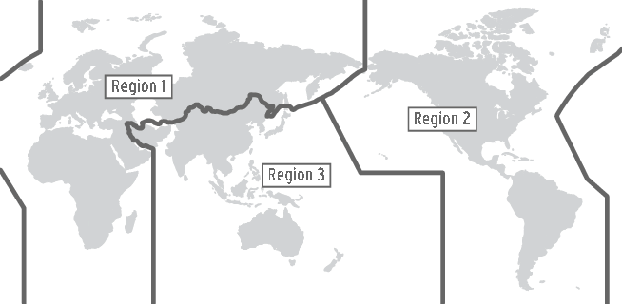

All international transmission may only contain information of a technical or personal nature. ITU regulations limit amateurs outside Canada (and the USA) without proficiency in Morse code to frequencies above 30MHz.

### Miscellaneous

Radio controlled models may be operated by amateurs. The use of such models are restricted to frequencies above 30 MHz (Section 54 of the Regulations). A related provision, Section 59 of the Regulations, provides that an amateur radio station shall not transmit an unmodulated carrier below 30 MHz except during brief tests.

### Q Signals

RBR-4 contains a list of Q signals which abbreviate a detailed question or answer. Many of these are never used. However, for the exam you should familiarize yourself with the following more commonly used Q signals which appear in the following table. Other abbreviations may be used during communication as long as they don't obscure the meaning of a message.

*Table 2 Q Codes*

|  |  |  |  |
| --- | --- | --- | --- |
| Q Code | Question | Answer | Suggested mnemonic |
| QRZ | Who is calling me? | You are being called by... | You are taking a snooze when you faintly hear someone saying your call sign. You would say "who is calling me" or QRZ. |
| QSO | Can you communicate with ...? | I can communicate with ... direct. (or relay through...) | SO, can you communicate with "SO and SO"? |
| QRM | Are you being interfered with? | I am being interfered with. | Q Radio Man-made interference or static. |
| QRN | Are you troubled by static? | I am troubled by static. | Q Radio Natural interference or static. |
| QRS | Shall I send more slowly? | Send more slowly (... wpm) | Q Radio Slower? |
| QTH | What is your position in latitude and longitude (or according to any other indication)? | My position is ... latitude, ... longitude (or according to any other indication). | Q The Home |
| QSL | Can you acknowledge receipt? | I can acknowledge receipt. | Can you acknowledge receipt of the QSL card? |
| QRG | Will you tell me my exact frequency (or that of ...)? | Your exact frequency (or that of ...) is ... kHz or MHz. | Can you tell me the exact frequency of my RiG—hence QRG. |
| QRT | Shall I stop sending? | Stop sending. | Q Radio Terminate |
| QRO | Shall I increase my transmitter power? | Increase your transmitter power. | Shall I Ridiculously Overload (increase) power? |
| QRP | Shall I decrease my transmitter power? | Decrease your transmitter power. | Shall I Reduce Power? |
| QSY | Shall I change frequency? | Change frequency to... |  |
| QRH | Does my frequency vary? | Your frequency varies. | Does my Radio Hold frequency? |
| QRI | How is the tone of my transmission? | The tone of your transmission is:  good,  variable,  bad. | Radio Intonate. |
| QRK | What is the intelligibility of my signal (or those of ....)? | The intelligibility of your signal (or those of ....) is .... | Radio Klearly. |
| QRX | When will you call me again? | I will call you at ..... hours (on ..... kHz). |  |
| QSP | Will you relay to ....? | I will relay to ..... | Send / Pass. |
| QSA | What is the strength of my signal (or those of ....)? | The strength of your signal (or those of ...) is ... | Signal Amplitude. |
| QRV | Are you ready? | I am ready. | Ready and aVailable. |
| QSK | Can you hear me between your signals and if so can I break in on your transmission? | I can hear you between my signals, break in on my transmission. |  |
| QTC | How many telegrams have you to send? | I have ... telegrams for you (or for ....) | Telegram Count. |
| QSB | Are my signals fading? | Your signal is fading. | Fading is often due to signals being received out of phase due to multipath. You could relate this as signals bouncing. |

## Operating Procedures

### Emergency Communications

Several classifications for emergency communications exist. Attached to each classification is a particular emergency signal to be transmitted by the station in trouble to attract attention and help. In order of importance they are:

#### Distress

This classification covers situations where there is grave and imminent danger, and need of immediate assistance. A station in this situation transmits the word "Mayday" three times and then gives its call sign. This procedure is repeated until a response is received. Distress ("Mayday" or “SOS” via Morse code) is to be given absolute priority over all other transmissions.

#### Urgency

Situations involving a very urgent message concerning the safety of a person, place, vehicle, plane, or vessel are considered to be within this classification. The signal is "Pan Pan" given three times. Urgency is given priority over all other transmissions except Distress.

#### Safety

This lowest classification of the three involves communications concerning safe navigation or weather advisories. The signal transmitted is "Security", repeated three times.

In the event of an emergency where an amateur may transmit in any band whether they have have permission to or not and may use as much transmitting power as necessary to get communications across. During disasters most communications are handled by nets using predetermined frequencies in the amateur bands when normal communication systems are overloaded or damaged. Operators not directly involved with disaster communications are requested to avoid making unnecessary transmissions on or near frequencies being used for disaster communications. It is permissible to interfere with the workings of another station if your station is directly involved with a distress station

During peace time and civil emergencies and exercises, messages from recognized public service agencies may be handled by amateur radio stations

***Note:*** *Section 9(1) of the Act makes it an offense under the Act to send any false or fraudulent distress signal. Any person transmitting a false signal may be liable for a fine of $5,000 and/or one year in jail.*

### Call Signs

Call signs are assigned by the respective governments of each country; however, the actual prefixes are agreed to by international convention. This international allocation process makes it easy to identify the location of a station. For example, some of the prefixes assigned to Canada are "VE", “VA”, "VY" and "VO". The Northwest Territories gets VE8; British Columbia gets VE7 or VA7; Alberta gets VE6; and so on. In Canada, the default call signs are 6 characters long with older or vanity call signs comprised of fewer characters. A license holder may have more than one call sign.

# Station Assembly

## Introduction

Amateur radio stations vary from the simple to the extremely complicated and expensive. Chapter two will describe the simple stations with an emphasis on the fundamental components of the radio station and will conclude with a few comments about safety.

## Station Components

### Transceiver

This is the heart of a station. It is a radio which contains both a receiver and a transmitter and its component parts are discussed in Part III.

### Microphones

Microphones are used to convert sound into electrical energy. Several types of microphones have been used for radio, including carbon, condenser, dynamic and crystal microphones.

Carbon microphones use a mass of carbon pellets behind a diaphragm whose resistance varies as sound waves apply pressure to the carbon. Electret condenser microphones use a capacitor whose capacitance varies in accordance with the sound it receives. Dynamic microphones are constructed in a similar manner to a speaker; there is a winding in the presence of a magnetic field. When sound moves this coil, a voltage is induced in it.

Finally, a crystal microphone uses a piezoelectric crystal that produces a voltage when it is mechanical stressed by the audio waves.

Sounds are usually considered to be a set of numerous frequency components at various levels. Human hearing is generally considered to fall in the range of 20 Hz to 20 kHz, although many people may have a normal range of 50 Hz to 15 kHz. For normal voice communications, a system with a frequency response of 300 Hz to 3 kHz will transmit voices with sufficient fidelity for comprehension. Reduction of this bandwidth may make the message unreadable.

### Low Pass Filter

This device is more fully described in Part IV, Interference and Suppression. It is designed to prevent the passing of high frequencies (greater than 30 MHz) from the transmitter to the antenna. In theory this item is required; however, in practice it may not be necessary. Most modern transceivers already contain such a filter, and additional one is generally unnecessary.

### Standing Wave Meters

Generally, this does two things:

* Measure the transmitter's output power; and
* Indicate how well the antenna is working.

The meter will indicate that your coaxial cable has become damaged or if part of your antenna has fallen down. A high Voltage Standing Wave Ratio (VSWR or SWR) indicates that there is a poor impedance match between your antenna and the transmission line, and that a portion of the transmitted power is being reflected back from the antenna to the transmitter. If this impedance mismatch is not corrected with some form of impedance matching device, the incomplete transfer of power from the transmitter to the feed line will occur, reducing the efficiency of the system. As well, without an impedance matching device, an undesirable heating of the final stage of the transmitter circuit will occur. An acceptable SWR is general considered to be between 1.0 and 1.5.

The SWR is directly dependent on the impedance mismatch (ie between a transmitter and an antenna), if the antenna has an impedance of 200 ohm sand the transmitter has an impedance of 5 ohms the SWR will be 4:1.

### Antenna Switches

While not a necessity, these switches allow you to conveniently select one of many antennas to be used with the transceiver without manually disconnecting cables. An antenna switch can be use to allow a receiver and transmitter to operate on the same antenna and should prevent the receiver from operating while the transmitter is selected and vice versa.

### Antenna

The antenna converts electrical signals to electromagnetic waves and vice versa. When transmitting the electrical power from the transmitter is radiated from the antenna and on reception a small amount of power is intercepted and converted into a voltage.

### Antenna Tuner

The antenna tuner allows an antenna to be operated over a wide bandwidth with a low SWR, increasing its efficiency.

### Dummy Load

The dummy load can be connected to your transmitter in the place of an antenna and simulates an antenna in all respects except that it does not radiate. It usually has a 50 ohm impedance and it will have a low SWR of 1:1. The purpose of this device is to allow you to tune up or to test and adjust your transceiver without actually transmitting a signal on the air.

### Frequency Counter

This device calculates the frequency by counting the number of times an electronic signal reverses polarity in a certain time. If this unit was connected (properly and safely) to a household electrical socket, it would measure 60 cycles per second (60 hertz). In a radio station the frequency counter would measure radio frequencies in the order of kilohertz and megahertz.

### Ammeter

Electric current is similar to the flow of water through a pipe. To measure the amount of water flowing through the pipe in a given time you need to cut the pipe. Similarly, an ammeter measures electric current flow and must be connected in series with a circuit and will appear as a low valued resistor in the circuit.

### Voltmeter

In the same way that water at a high elevation flows to a lower elevation, electrons flow from higher energy potentials to lower energy potentials. Electric energy potential is voltage, and it is analogous, to the height of water above the ground. To measure voltage, you need to connect the ends of the voltmeter parallel to a component or across 2 nodes within the circuit. A multimeter will contain both a voltmeter and an ammeter, as well as be able to measure resistance.

### Oscilloscope

Amateur radio operators may need to observe the behavior of electronic signals over time. Like a seismograph plots on a roll of paper the magnitude of vibrations in the ground during an earthquake, an oscilloscope plots voltage as a function of time on a video screen.

*Figure 2 Amateur radio station*

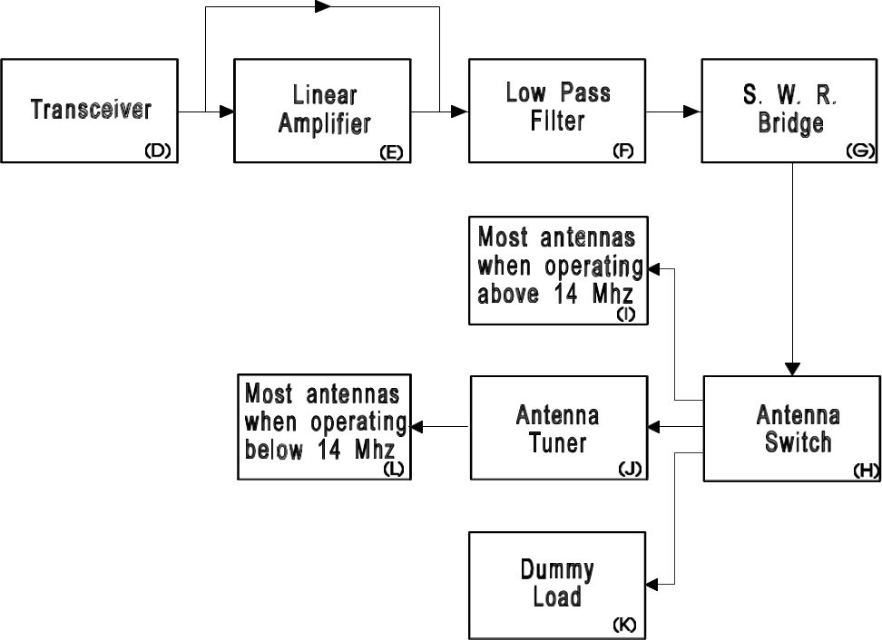

## Station Safety

Keep in mind at all times that the equipment employed in an amateur station may contain very high voltages. These voltages are high enough, with sufficient current, to kill you or anyone else careless enough to touch the wrong place. Unless you know what you are doing keep your fingers and any other conducting material away from the insides of power supplies, amplifiers and transceivers.

When installing your radio equipment, remember that you must have 110 volt receptacles that are grounded and equipped to accept three pronged plugs. Do not use extension cords which do not accept the third prong. The grounding prong is important in the event of an electrical short between the equipment and the chassis, having the radio grounded through the plug will keep the chassis from becoming "hot" and electrocuting anyone who touches it.

Your station can also have an RF ground to increase performance and safety during lightning strikes. All modern equipment has a grounding post on the back panel which can be connected to a good ground with a thick copper wire. A good ground is generally considered to be a copper rod or pipe approximately 3 meters (10 ft) in length pound this into the ground as close to your station as possible to keep your grounding wires as short as possible. If you have a long ground wire you can develop high RF voltages across the ground, reducing its usefulness. This becomes important if the antenna is hit by lightning by providing a low resistance path to ground, and if paired with a lightning arrestor, can prevent high currents from passing through your equipment.

# Basic Electronics

## Fundamental Concepts

### Conductors and Insulators

*Conductivity* is a material’s ability to conduct an electric current. Insulators will not pass a current, but conductors will. Current is the rate of the flow of the charge, and is measured in coulombs/second or amperes (a coulomb being the unit of charge). Materials which exhibit a conductance between that of a good conductor and that of a good insulator are called semiconductors.

*Figure 3 Conductivity*

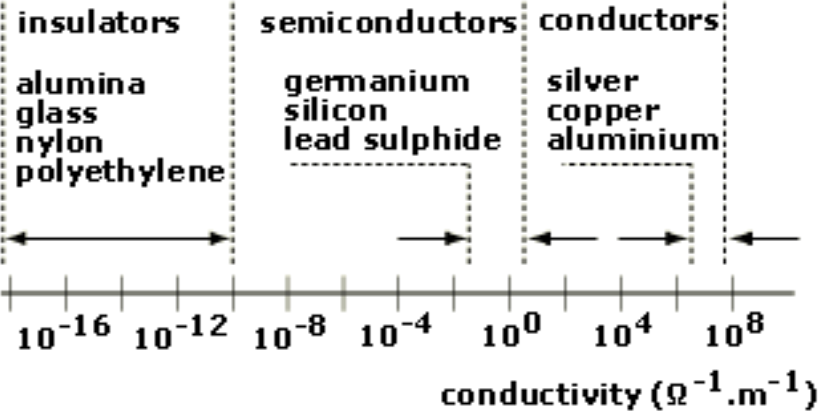

### Electromotive Force (E) and Power (P)

*Electromotive force*, measured in volts (V), is equal to the amount of energy transferred by moving a unit of charge through a circuit. The rate of energy transfer is called power (P) and is measured in *watts (W)*. *Power* is the mathematical product of voltage and current and indicates how fast energy is being used in a circuit.

**Power = (Voltage) x (Current) or P = E x I**

**P = V^2/R = I^2/R**

Power can also be measured using a mathematical ratio called a decibel (dB) with a 3dB gain representing a doubling of power and a 10dB gain representing a 10x gain in power. For example, if a signal has a 6 dB gain, it will be 4 times more powerful than the original and if it has 20dB gain it will be 100 times more powerful.

### Frequency

Frequency is a measure of how often an electrical signal alternates back and forth. Measured in Hertz (Hz) or cycles per second, as the frequency increases the number of Radio frequencies have a property called wavelength which is proportional to the speed of light (3X10^8 m/s) divided by the frequency, measuring how far a signal will travel during one complete cycle. (eg. 30MHz has a wavelength of 10 meters) Lower frequencies have longer wavelengths.

### Alternating Current (AC) / Direct Current (DC)

Currents can be *alternating*, *direct*, or a combination of both. Direct current remains constant where alternating current varies in time, flowing in both the positive and negative directions, most commonly following the sine function.

*Figure 4 AC/DC*

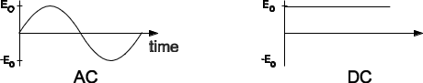

Where: EO is the peak positive and negative value in volts

*f* is the frequency of oscillations in cycles per second, hertz (Hz)

t is the time in seconds (s)

For AC, the average of E(t) over a long period of time is zero. The current goes back and forth within the circuit. In contrast, DC flows in one direction.

### Resistance and Impedance

*Resistance* (R) is the opposition that current meets when traveling through a material. Measured in *ohms* (Ω), resistance mathematically relates voltage to current in energy dissipating devices like resistors. Low resistance materials allow current to flow easily. The reciprocal for resistance is conductance, which measures how easily current can flow in a material.

*Reactance,* is similar to resistance but relates voltage to current in inductors and capacitors connected to an alternating current source. Inductive reactance (XL) and capacitive reactance (XC) depend not only on the value of the component, but also on the frequency of the voltage that is applied to the device. Inductive reactance (XL) increases as the AC frequency increases, Capacitive reactance (XC) decreases as frequency increases. For example, at 60Hz a 25 microfarad capacitor has a reactance of 106.1 ohms.

*Figure 5 Reactance*

Capacitors and inductors are non-dissipative components. They store energy and release it again at a later time. One consequence of this behavior is that the current through the component and the voltage across it are not in phase with each other. In other words, the peaks of the voltage and current sine waves will occur at slightly different instances in time. In a purely resistive component, the current and voltage remain in phase. In a purely inductive component, the voltage leads the current by 90o. In a purely capacitive component, the current leads the voltage by 90o. Since the capacitive and inductive reactances are 180o out of phase (+90o and -90o), they partially or completely cancel each other when both are present in a circuit.

*Impedance* (Z) is the general term which mathematically relates current through and voltage across a circuit. Impedance may include resistance (R), inductive reactance (XL), and capacitive reactance (XC).

*Figure 6 Impedance*

*Resonance* occurs in a circuit containing both inductive and capacitive reactance at the frequency where the two reactance’s are equal (XL = XC). This occurs at one frequency and is characterized by a high impedance in a parallel tuned circuit and a low impedance in a series tuned circuit.

*Figure 7 Resonance*

*Figure 8 Resonant Circuits*

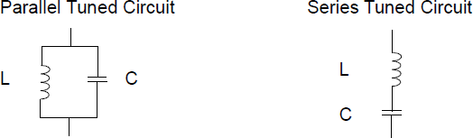

## Ohm’s Law

*Ohm's Law* relates voltage (E) in volts (V), current (I) in amperes (A), and resistance (R) in ohms (Ω) using the following formula:

*Figure 9 Ohm’s Law*

As an example, suppose a 6 ohm resistor is connected across a supply of 12 volts. Ohm's Law predicts a current of 2 amperes.

*Figure 10 Amperes*

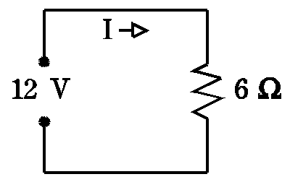

If a second resistor is connected to the same source it is said to be connected in *parallel* with the first resistor. The voltage across each resistor is still 12 volts. The current through each resistor can be added up to find the total current in the circuit. As shown in the following calculation, the current through the 3 ohm resistor is 4 amperes. The total current is 6 amperes.

*Figure 11 Parallel resistor*

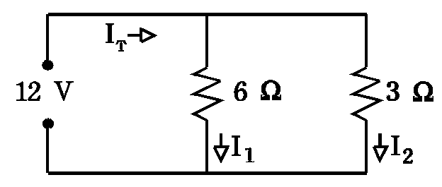

Consider the following circuit. If a single resistor is connected to the 12 volt source you would need resistance of 2 ohms to have a current of 6 amperes. Notice that the two circuits have the same current of 6 amperes. In other words, a 6 ohm and 3 ohm resistor connected in parallel have a total resistance of 2 ohms.

*Figure 12 Single resistor connected to a 12V source*

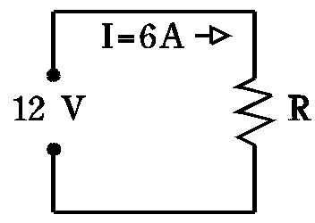

The standard formula for the equivalent resistance of any number (N) of parallel resistors.

*Figure 13 Resistors in parallel*

Where RT is the total resistance. Similarly, any number (N) of resistors in series will have an equivalent total series resistance. The total resistance will always be smaller than the smallest resistance. If equal valued resistors are placed in parallel the total resistance is equal to the resistance value divided by the number of resistors.

*Figure 14 Resistors in series*

With a series circuit, each resistor passes the same current, and the voltages across each resistor adds up to the supply voltage. The total resistance of series resistors will be larger than any one of the resistors.

## Electronic Components

### Resistors

A resistor is a device usually made form carbon that is inserted into a circuit to provide resistance to the flow of current. Resistor values are usually marked using a 3 color band system tom indicate the value and a fourth to indicate the tolerance of the measurement (eg. +/-10%). For example, using the color code below a resistor having the colors Brown Black Brown Silver and has a value of 100 ohms +/- 10% (90 – 110 ohms). Resistor values (and wire resistance values) are weakly temperature dependent and as the temperature changes, so will the value.

*Figure 15 Resistor color codes*

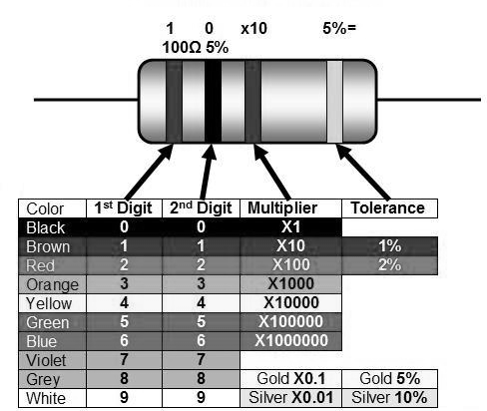

When in use, resistors may get hot because they will absorb and dissipate power proportional to their resistance and the square of the current flowing in them. The amount of power a resistor can dissipate is related to the size of the device, as the resistors get bigger, they can dissipate more power. Resistors will have a voltage drop across them which leads to a difference in voltages across the terminals.

When multiple resistors are added into a circuit, in either series or parallel configuration, the total power than can be dissipated is equal to the individual powers.

### Capacitors

A capacitor consists of two parallel, conductive plates separated by a dielectric (often air, paper or plastic). A voltage exists between the two plates if the plates are oppositely charged. To change the voltage between the plates a current from an external circuit is required for a period of time. Once charged, the capacitor will remain charged until some connection is made to discharge it. Capacitance, measured in farads (F), is the ratio of the charge, in coulombs, contained in the capacitor to the voltage across its plates. The most common values are in the range of picofarads (1 pF = 10-12farads) or microfarads (1 μF = 10-6farads). Capacitors in series decrease in value and parallel capacitors add together.

The value of a capacitor is determined by the material between the plates, the area of one side of the plates, and the distance between the plates.

*Figure 16 Capacitors in series*

*Figure 17 Capacitors in parallel*

### Inductors (chokes)

A current in a conductor will invoke a proportionally strong magnetic field around it. If the current is suddenly removed, the collapsing magnetic field will induce a voltage in the wire in a direction opposite to the original current. The creation of an opposing voltage due to a changing current is called inductance. The unit of inductance is the henry (H). Values of common inductors are in the range of millihenries (1 mH = 10-3H) or microhenries (1 μH = 10-6H). Similar to resistors, series inductors will add in value and parallel inductors will have a lower value.

*Figure 18 Inductors in series*

*Figure 19 Inductors in parallel*

The conductor can be wound into one or more loops to increase inductance. Inductors for low frequencies often use a *ferromagnetic core* around which the conductor is wound. This core may have one of many shapes (such as two "E"s or a toroid (doughnut)) and may be made from *ferrite*, powdered-iron, or laminated iron plates. These cores are used to increase the inductance, to control stray coupling by conducting the magnetic field, and to accurately obtain a specific inductance or to vary the inductance.

The value if an inductor depends on the number of turns, the core material and the core diameter.

### Transformers

A *transformer* is a set of two or more coils (often called windings) wound on a common core. The input coil, which introduces the energy to the transformer, is called the *primary,* whereas the output coil is called the *secondary*. Transformers are used to change a voltage or to provide isolation between two circuits. The ratios of voltages and currents in the primary and secondary are given by the formula in Figure 20. Power used by a load (ie. A resistor) on the secondary will be supplied by the primary.

*Figure 20 Ratio of voltages and currents in the primary and secondary*

Transformer cores for power line frequencies (60 Hz) are usually made of stacks of thin steel plates and transformers designed for higher frequencies use ferrite cores. This lamination makes for higher transformer efficiency by reducing eddy currents. Typically, for 120 volts, the primary of the transformer will have 200 turns or more. Ignoring losses, the power into a transformer equals the power out.

Transformers are not 100% efficient and will draw current even if there is no load on the secondary, this is due to what is called the magnetizing current. The transformers inefficiency can be seen in the heating of the iron laminations in the core while it is in use.

### Vacuum Tubes

The simplest vacuum tube consists of a *filament* (heating element) that heats a *cathode* (source of electrons), and a conductive *plate* (destination for electrons) enclosed in an evacuated glass *envelope*. When connected to an appropriate power source, the filament heats the cathode allowing it to release electrons through *thermionic emission*. If the plate is connected to an external circuit and positively charged with respect to the collector, the electrons will flow from the cathode through the vacuum to the plate. Since electrons can only originate from the cathode, current can flow only in one direction, from the plate to the cathode. This simple device is called a *diode*.

*Figure 21 Diode, triode, and pentode*

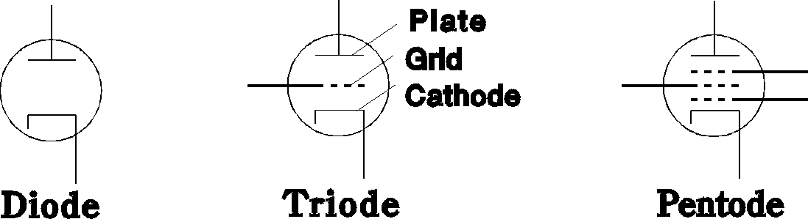

If the tube has another element, called a *control grid*, it is now called a *triode*. The control grid is a wire mesh placed between the cathode and plate allowing the triode to become more or less conductive according to the control grid's voltage. The grid voltage potential (bias voltage) will be less than that of the plate and to completely cut off current flow, between the plate and cathode, can be brought below the cathode voltage. This is the basis of *amplification*. Other tubes such as *tetrodes* and *pentodes* also exist and have more grids than the triode. At one time vacuum tubes were the only active devices but in current equipment, have been almost completely replaced by semiconductor devices. Vacuum tubes are still preferred in some applications due to their high power operation and resilience under adverse conditions. It is most common to find tubes in commercial transmitters that deliver 25 kilowatts or more of RF power. Vacuum tubes require high voltages to operate, sometimes up to 2kV, making them unsuitable for some applications.

### Semiconductors

Semiconductors have almost completely replaced vacuum tubes in modern electronics due to their low power consumption, large scale miniaturization, and shock-resistance.

Semiconductors are alloys manufactured by combining pure *silicon*, *germanium*, and *gallium arsenide* (which are normally poor conductors) with impurities such as *boron*, *indium* and *arsenic*.

### Diodes

*Figure 22 Diodes*

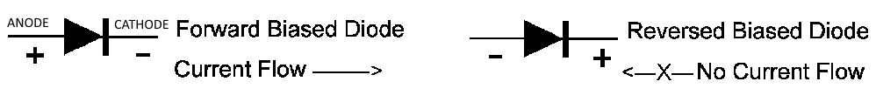

Solid state diodes are the most basic type of semiconductor device and are widely used in nearly every piece of electronic equipment made. Diodes are favored in electronic equipment because they can be used for converting AC to DC. When forward biased they allow conventional current flow in one direction (Anode to Cathode) and prevent current from flowing in the reverse direction. Diodes used in high current applications (i.e. in power supplies and in car alternators) are made from silicon. Diodes for smaller signals use silicon or germanium. The most exotic material, gallium arsenide, has a low barrier potential useful for low noise, high frequency applications. Diodes can also be used to demodulate AM transmissions as an envelope

*Zener* diodes are special diodes which exhibit a sharp rise in reverse current above a fixed voltage (the zener voltage), this special property makes zeners well suited for voltage regulation. They are usually found in regulated power supplies and other circuits requiring regulation or voltage reference.

### Transistors

Transistors have replaced tubes as the main active component in modern electronics. A varying input signal at the transistor's control terminal results in a proportionally larger change in current at the output terminal allowing the amplification of small signals. Two main sub-classifications of transistors are *field effect transistors* (FETs) and *bipolar transistors*. J-FET and MOSFET are the two common types of FETs, each type being available in both N-channel and P-channel polarities. Similarly, bipolars come in NPN and PNP polarities. The symbols for each device as well as the names of their terminals are shown in the Figure 23.

*Figure 23 Bipolar transistors in NPN and PNP polarities*

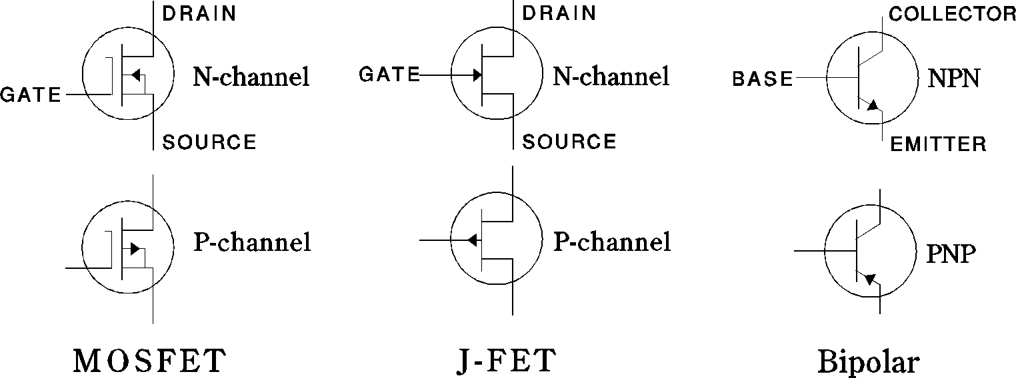

Transistors can be compared to triode vacuum tubes as both devices can amplify small signals, with the FET being the closest to the vacuum tube. Bipolar transistors have a base that controls the device similar to the grid of a triode, a collector that is similar to the plate, and an emitter that is similar to the cathode. Field effect transistors have a gate that controls the conductance of the channel with charge carriers entering the channel from the source and exiting the channel via the drain. A FET source pin is similar to the bipolar transistor emitter and the drain is similar to the collector.

Transistors may still require cooling as they are more susceptible to over-temperature then vacuum tubes. In larger devices, 10-100 watts may be dissipated internally as heat.

Transistors can be cooled by bolting a *heat sink* (finned piece of metal) to the component. *Thermal runaway* (failure to maintain a reasonable component temperature) may cause the component to fail. Thermal runaway occurs when a semiconductor’s resistance decreases as the temperature increases. The decrease in resistance leads to more power being dissipated across the device, increasing the temperature further.

### Integrated Circuits

*Integrated circuits*, or ICs, are composed of hundreds or thousands of microscopic transistors and other components in one small package. An IC will typically have between eight and forty pins and will perform a specific function within a circuit. "Chips", as ICs are sometimes called, should be handled with care as they are often susceptible to damage from static electricity.

### Batteries

A battery (or storage cell) is a device that stores energy for later use and allows a piece of equipment to be operated away from other power sources. The most common style of battery used in amateur radio is the lead acid automobile battery having a voltage (EMF) of around 12V and can be recharged for repeated use. Batteries that can be recharged are known as secondary cells, batteries such as carbon-zinc cells are known primary cells and cannot be recharged. Batteries have an internal resistance which can cause the output voltage to fall when large currents are being drawn, limiting the output current. The current from batteries can be increased by placing them in parallel and the voltage can be increased by placing them in series.

A rechargeable battery sometimes found in radio equipment is the nickel-cadmium battery, for long operating life this battery should not be allowed to discharge past 1V per cell and should never be short circuited.

## Power Supplies

Since electronic circuitry uses direct current (DC), but the standard Canadian line supply (household wall sockets) is 120 volts AC at 60 Hz, a power supply is required to convert the AC supply to DC. Typically, solid state equipment requires between 5 and 15 volts DC; high power tube amplifiers require several thousand volts DC. The ideal DC output voltage from a power supply should be free from noise and ripple, and should be regulated to ensure a constant output voltage under a wide range of current loads or slight fluctuations of the input voltage.

There are three main components in a conventional power supply:

* Transformer;
* Rectifier; and
* Filter capacitor

The block diagram shown below illustrates a typical amateur radio power supply with these three stages (labeled B, C, and D respectively). In some cases the output voltage is regulated to a specific voltage by a regulator. Memorize Figure 24, paying attention to how each building block of the circuit fits within the system.

*Figure 24 Regulated power supply*

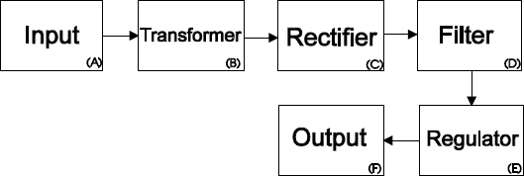

The transformer alters the input supply AC voltage (to a higher or lower AC voltage at the secondary. This secondary voltage roughly determines the voltage of the power supply output. The transformed AC supply is then rectified by the use of one or more silicon diodes. There are three standard rectifier diode configurations: half-wave, full-wave, and full-wave bridge rectifiers.

The rectified voltage is still unsuitable for use in electronic circuitry because it isn’t constant over time. The series of peaks and discharges are referred to as ripple. The magnitude of the ripple is inversely proportional to the capacitance of the filter. To achieve a constant DC Voltage with minimum ripple, filter capacitors are added to the power supply. During the voltage peaks in the rectified supply, the capacitors are charged to this peak value. Between the peaks, the capacitors discharge according to the demands of the circuit until the next peak begins to charge the capacitor. If a large amount of ripple is present on your power supply your device may make a low frequency humming noise.

Some power supplies for vacuum tube equipment does not include a transformer, special care needs to be taken with these devices as one of the line cord is sometimes attached to the chassis.

If your AC supply voltage is incorrect and you want a higher or lower AC input voltage, a device called an auto transformer can be used to increase or decrease the voltage.

Care should be taken when working with high voltages (30V+) as these voltages can carry enough power to cause damage to the human body and power supplies should not be worked on while the power is on. Currents as low as one tenth of an amp can be fatal passing through your body, with the heart being the most sensitive organ. If someone has been burned by high voltage turn off the power, call for emergency assistance, and give CPR if needed. Do not touch a person who is contact with high voltages as the voltage can pass through their body and cause the rescuer harm.

*Figure 25 The effect of filter capacitors on power supply ripple*

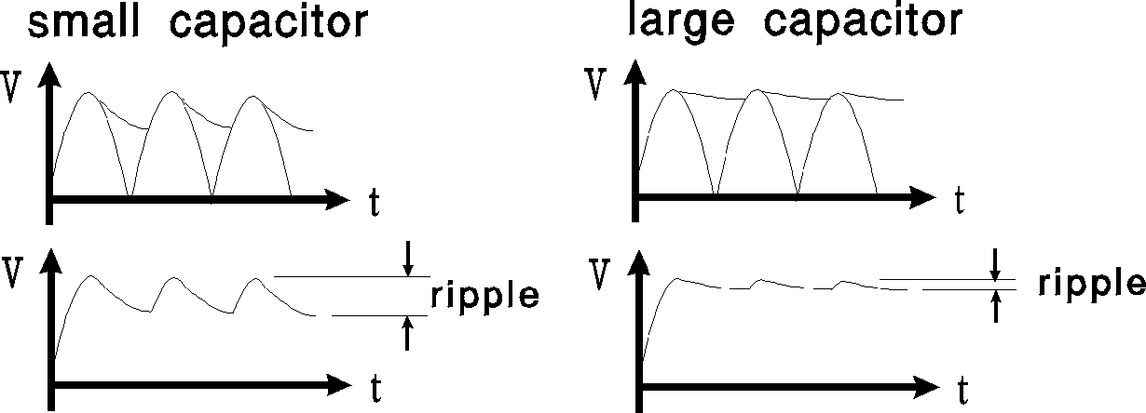

For safety reasons, the chassis of the power supply is normally grounded to minimize the chance of electrocution in case the equipment malfunctions. Interlock mechanisms are used on high voltage power supplies to ensure that potentially lethal voltages are not present when the cover is removed. Bleeder resistors are connected across the filter capacitors in the high voltage supplies to speed their discharge once the equipment is shut off. Fuses are used to protect the equipment in the event of an overload caused by human error, equipment failure, or act of God.

## Transmitters

### Introduction

Radio involves the transmission of audio, video, telegraphy, or data information from one location to another. This information is often referred to as the message signal or *baseband* signal. Before it can be transmitted, the signal must be converted to a radio frequency (RF) signal. This process, called *modulation*, involves the original information signal and a continuous, stable, and pure RF sine wave known as the *carrier*. This carrier determines what frequency the station transmits on.

Modulation is the process of varying one or more properties of the carrier signal based on the value of the baseband signal. Common means of modulation are either Frequency Modulation (FM) or Amplitude Modulation (AM).

One fundamental concept of radio theory is that, even though a pure carrier exists at one discrete frequency, any modulation of this carrier will produce a signal of finite *bandwidth*. Simply put, if useful information is being conveyed with the carrier, then spectrum must be occupied. Different modulation schemes and different message signals use differing amounts of bandwidth. The bandwidth of an amateur transmission is determined by the frequency band occupied by that signal to a level of 26dB below the maximum amplitude of that signal.

In the transmission of voice (telephony), the original voice waveform is converted to a radio frequency (RF) signal by the transmitter. This is achieved through a minimum of three stages:

* RF oscillator;
* Modulator; and
* RF power amplifier.

The RF generator or *carrier oscillator* produces the carrier. This oscillator should be electrically and mechanically stable to prevent frequency drift. The baseband signal is converted to a radio frequency signal by the modulator. At this point, the signal is still at a very low power level (likely in the order of 1 mW) and could be received easily over only a very short distance. The RF power amplifier increases the power of the radio frequency signal to a sufficient level for reliable reception by a distant station.

## Continuous Wave (CW)

*Figure 26 Carrier Oscillator*

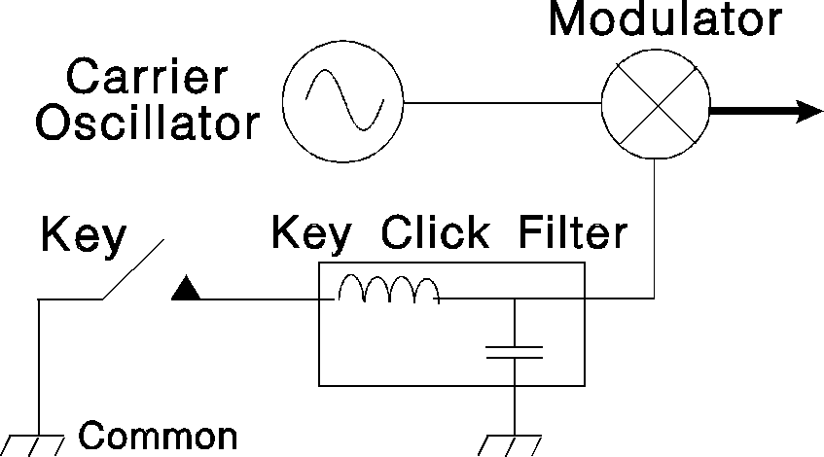

The simplest method of modulation is on-off keying (O.O.K.), which is used in the transmission of Morse code. A simple key switch is fed to a modulator that is controlling the passage of the carrier through the rest of the transmitter. When the key is pressed, the transmitter sends the carrier. When the key is released, the transmission stops. Abrupt changes in the amplitude of the carrier will increase the normal bandwidth of the signal. This causes interference on adjacent frequencies. Historically this problem was cured by the use of a *key click filter* between the key and the transmitter reducing the rise and decay times of the carrier. The filter is usually constructed with an inductor and a capacitor forming a low pass filter.

Modern transceivers are constructed to eliminate the possibility of such a problem. This has rendered key click filters obsolete.

One common problem with CW transmitters is “*chirp*”, which refers to a small change in the transmitters frequency whenever the transmitter is keyed. This is caused by fluctuations in the power supply voltage and can be avoided by keeping the power supply voltage stable.

Memorize Figure 27, paying attention to how each building block of the transmitter fits within the system.

*Figure 27 CW Transmitter*

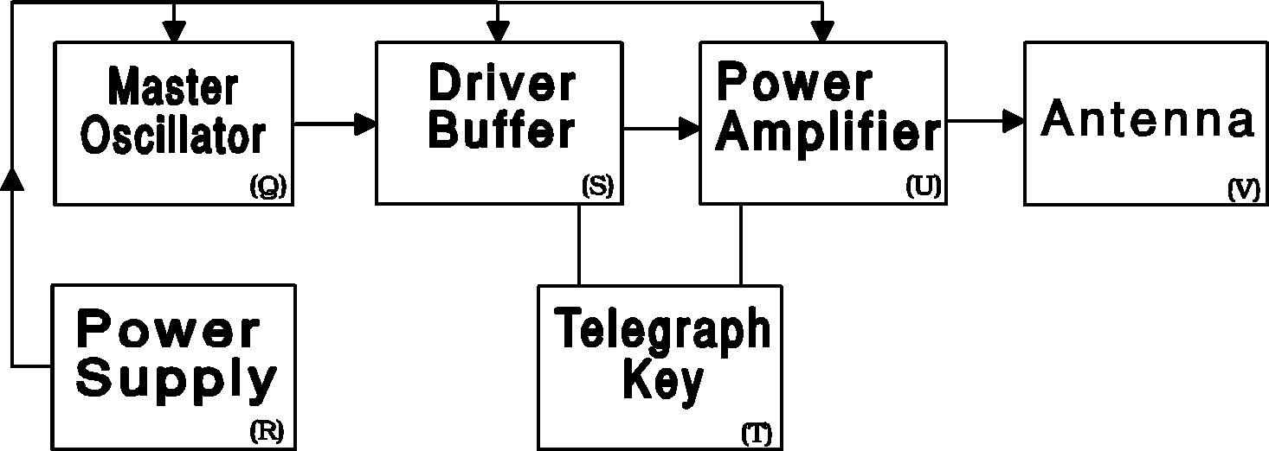

### Amplitude Modulation (AM)

A carrier may be changed in amplitude directly by a baseband waveform, this is known as *conventional amplitude modulation*. When there is no signal at the input to the transmitter, a steady carrier is produced at the output of the modulator. When there is an input signal, the modulator changes the magnitude or *envelope* of the carrier over time. A simple representation of amplitude modulation is shown in the diagram below. For normal operation it is understood that the envelope of the carrier must not reach zero, this can occur when the microphone gain is set too high. This case, called *overmodulation*, must be avoided to ensure adjacent users are not interfered with by *splatter*. An overmodulation indicator should be used on AM transmitters not having automatic modulation control.

The bandwidth of an AM signal will occupy twice the highest frequency sent to the modulator. Normal telephone grade voice signals contain frequencies up to 3kHz. This signal, when modulated using amplitude modulation would occupy 6kHz of bandwidth. The AM spectrum is made up of two symmetrical sidebands: an *upper sideband* (USB) and *lower sideband* (LSB). Low frequency audio is contained closest to the carrier. The highest audio frequency components are contained in the part of the sidebands furthest away from the carrier.

A variation of Amplitude Modulation is called Pulse-Amplitude Modulation (PAM) in which a series of sharp pulses at the carrier frequency whose amplitude is varied by the baseband signal.

*Figure 28 Amplitude modulation*

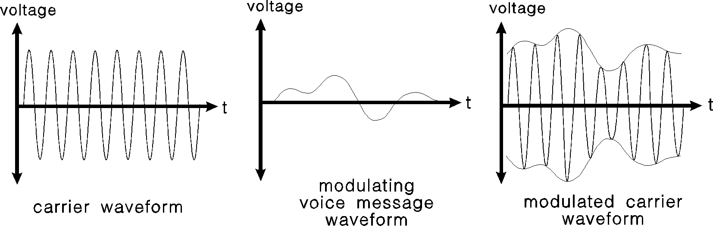

### Single Sideband (SSB)

Although conventional AM can be recovered at the receiving end through very simple means, the transmission of such modulation is not power or bandwidth efficient. The carrier contains a significant amount of the transmitted power, but relays no information. Its sole use is to simplify receiver design and aid in demodulation. Additionally, both sidebands, being symmetrical, contain exactly the same information but occupy twice the bandwidth of the baseband signal.

If the carrier and one sideband can be eliminated, the same message can be transmitted with much less average power and half the bandwidth. This method of modulation is called single sideband or SSB and it has a bandwidth of 2 to 3kHz, half that of AM transmission. Similar to AM, if the baseband signal over-modulates (greater than 100% modulation) the carrier the signal will occupy a larger bandwidth as well as generate harmonics and out of band transmissions.

Although there are several ways of generating SSB, the most common method uses a *balanced modulator* and a *sideband filter*. A block diagram representation of an SSB transmitter is shown in the Figure 29. The RF or carrier oscillator supplies a stable, fixed frequency to the balanced modulator. The microphone generates an electrical replica of the operator's voice message. This is amplified to a satisfactory level by the speech amplifier. The balanced modulator produces a double sideband suppressed carrier (DSBSC) signal.

Simply put, the balanced modulator removes the carrier, which is later re-inserted at the receiver. A sideband filter then removes the unwanted sideband. The remaining sideband will be either lower sideband (LSB) or upper sideband (USB), depending on which sideband mode has been chosen by the operator.

SSB transmitters will also contain an Automatic Level Control (ALC) circuit which controls the peaks of the audio signal so that the final amplifier is not overdriven, which can cause distortion in your RF output. The ALC is correctly adjusted when the ALC meter (not on all radios) moves only slightly on modulation peaks.

Memorize *Figure 29*, paying attention to how each building block of the transmitter fits within the system.

*Figure 29 Single sideband transmitter*

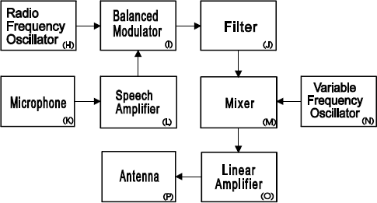

Now that the unwanted sideband has been removed, the signal is converted to the final output frequency by means of a mixer and a *variable frequency oscillator*. The VFO allows the frequency of the transmitter to be easily changed by the operator. The balanced modulator cannot be changed in frequency. The final signal is then amplified by the linear amplifier to the desired power level and fed to the antenna.

### Frequency Modulation (FM)

For local very high frequency (VHF) and ultra high frequency (UHF) communications, *frequency modulation, some*times referred to as phase modulation, is used almost universally. It is preferred for its superior noise immunity, ease of tuning, and high audio quality. Modulation is accomplished by varying the instantaneous frequency of the carrier directly in accordance with the message signal. The maximum limit of the instantaneous frequency in either direction is called the *maximum deviation*. It is usually +/- 5 kHz for normal two-way radio application but may occupy up to 10 – 20kHz for amateur communications. But maximum deviation may be as high as +/-12 kHz for cellular radio telephone, and +/-75 kHz for stereo FM broadcasts. This deviation limits the use of FM to frequencies above 29.5MHz as it exceeds the maximum allowed bandwidth for lower frequencies. Deviation outside the specified limits caused by overmodulation (ie. excessive microphone gain) will not only cause interference on adjacent channels but will also cause the received signal to sound distorted.

Memorize *Figure 30*, paying attention to how each building block of the transmitter fits within the system.

*Figure 30 Frequency modulation transmitter*

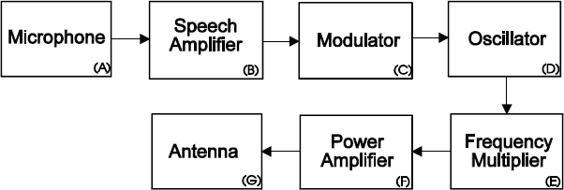

An FM transmitter involves a number of distinct stages. The microphone signal is first amplified by the speech amplifier to increase the signal power. The modulator and the oscillator then uses this input signal to vary the carrier frequency between the deviation limits. Since the oscillator is low frequency and since the modulator has, by design, low deviation, the signal is then multiplied in frequency by the frequency multiplier to the final transmit frequency. Typically, for 144 MHz transmitters, the crystal frequency will be 12 MHz, necessitating a multiplication factor of 12 times. The multiplier also increases the deviation of the signal, necessitating less than 500 Hz deviation at the modulator. After multiplication, the signal can then be amplified, as before, by an RF power amplifier.

Determining the occupied bandwidth of an FM signal is more complicated than simply considering the frequency of the message signal. In fact, one must consider both the frequency of the message signals and the deviation. It can, however, be approximated using Carson's rule:

where:

As an example, a 5 kHz deviation with a 3 kHz modulating signal occupies 16 kHz of bandwidth. In cases of very wide deviation, the bandwidth may be many times that of conventional AM. Very narrow deviation reduces occupied bandwidth to twice *fm*, the same as AM.

### Digital Modes

The most common digital modes which are used in amateur radio are radioteletype (RTTY), AMTOR (a variant on RTTY), and packet radio.

RTTY is the oldest of the machine generated digital modes and works by encoding characters into a digital code. The most common digital coding scheme used is Baudot, which uses a number between 0 and 31 to represent the various letters, digits and punctuation marks. In order to fit more than 32 different characters into the code, some numbers are used twice, with a special character used to switch between the two meanings. The number can be represented by a 5 digit binary number (i.e. 14 = 01110 in binary). To send a character over the radio, each bit (binary digit) is assigned to one of two tones (frequency shift keying (FSK)), and the audio output of each bit in succession is then fed to the modulator. The two states of a bit (0 and 1) are referred to as mark and space. The device that produces a tone for each state is called a modem. In order for the receiving end to be able to decode the character sent, the bits must be sent at a constant speed. Common speeds used by amateurs are 60 wpm, 67 wpm, 75 wpm, 100 wpm and 132 wpm. The two tones must also maintain a fixed frequency separation or shift. The most common shift used by amateurs on HF is 170 Hz and a spacing of 250 to 500 Hz should be used to reduce interference between transmitters.

*Figure 31 Digital transmission system*

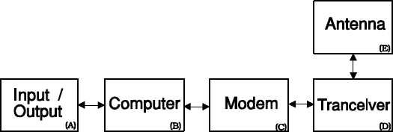

AMTOR is a form of RTTY that uses error checking to ensure that the data that is sent is received correctly. The message being sent is broken up into groups of 3 characters each. A checksum is calculated and appended to the group and the resulting small packet is then transmitted through a modem to the radio. The system can operate in two modes, A and B. Mode B checks the data but will not ask for a repeat and is used for establishing a contact (i.e. calling CQ). Mode A uses Automatic Repeat Request (ARQ) to ask the sending station to resend any packets that are not received properly once contact is established.

Packet radio is a system similar to AMTOR, but with more powerful error checking and message handling abilities. The system sends and receives larger packets and encodes in each the sender and destination addresses. Packets are assembled and prepared for transmission by a terminal node controller (TNC) connected to the transmitters microphone input. The individual characters are usually encoded in ASCII (not Baudot) and the packet format is usually set to the AX.25 protocol, though other formats do exist. The assembled packet is then passed to a modem and a radio in the same fashion as RTTY and AMTOR. The most common transmission rate for this mode is 1200 baud. Packet radio nodes can be connected in a network to transmit data over long distances. Digipeters can be used to retransmit packets that have been marked for retransmission. A transmission/reception pair is “connected” when the transmitter is sending information only to that station and the receiving station is replying that the data has been received. A station can be set to “monitor” mode where it will display all transmitted messages it receives, regardless of destination address.

### Power Amplifiers

Now that the message signal is modulated on a carrier, the RF signal must be amplified to a sufficiently high level for the receiving station to receive the signal with a suitably low level of noise. It should be noted that noise and signal degradation will be present on any realistic communication system. The quality of the recovered signal will depend on many factors including mode of emission, transmitter power, receiver quality, antennas and the path over which the signal travels.

The signal is first amplified with a *driver stage* and then with a *final power amplifier*. Amplifiers can provide gain for either current, voltage, or power

There are several classifications of power amplifiers. The selection depends on the type of modulation being used.

*Figure 32 Tank circuit*

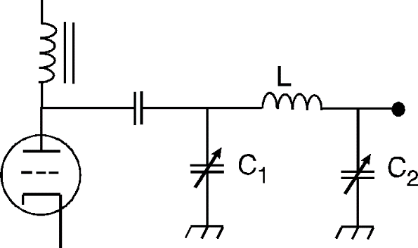

For frequency modulation, class C amplifiers are widely used due to their high efficiency. Since these are *non-linear,* and introduce distortion, they are not suitable for use with AM or single sideband. Non-linear amplifiers, when used with AM or SSB, distort the original signal, producing frequency components which were not originally present. For single sideband applications class A amplifiers are used because they exhibit good linearity.

For high power operation, above several hundred watts, tube amplifiers are sometimes used but are beginning to be replaced by solid state variants. These tube amplifiers normally obtain antenna matching and some degree of band pass filtering by the use of a *tank circuit*. The tank circuit, sometimes referred to as a *pi network*, is shown schematically in the Figure 29. The two capacitors are adjusted so the circuit will resonate at the transmit frequency and provide proper matching to the antenna.

Transistorized power amplifiers for HF use do not use tank circuits to provide matching to the antenna circuit. Instead they use small transformers. Harmonic filtering is accomplished by a low pass filter connected immediately before the output connector. This filter is designed to pass the transmit frequency but attenuate frequencies in higher bands.

No amplifiers are perfectly efficient, all of them dissipate or waste power. Of the DC power supplied to the amplifier stage, approximately half of the power will be converted to radio frequency, the rest is released as heat. This heat is removed from the amplifier either by natural convection, or by forced air cooling.

### Miscellaneous

Some transmitters have a function (VOX) which allows them to transmit automatically whenever the user speaks into the microphone. To help operators operating CW form proper characters, electronic keyers are some times used. Some operators chose to use speech processors to increase the average power level of a SSB transmission, and when properly configured, this can help to increase the ineligibility and quality of the received audio.

## Receivers

Now that a signal has been created and transmitted, it must be intercepted by an antenna and fed to a receiver. The RF signal is processed by the receiver to recover the original message.

The performance of a receiver is determined by three parameters, sensitivity, selectivity, and stability. Sensitivity is a measure of the receiver's ability to detect weak signals and is determined by the signal plus noise to noise ratio. The more sensitive the receiver is, the less noise it creates internally and the better able it is to receive weak signals. Selectivity is a measure of a receiver's ability to reject signals on adjacent frequencies without effecting the signal being received. Stability measures the receivers ability to accurately tune to a frequency and how much that frequency will change over the receivers life.

Modern receivers typically have six stages:

* a radio frequency (RF) amplifier;
* two conversion stages;
* two band pass filters; and
* a demodulator.

Such a receiver is called a *double superheterodyne* receiver, which means that the frequency on which the information is carried is *converted* twice. Conversion is accomplished with a mixer and a local oscillator. This may seem like a complicated method, but it is the most cost-effective means.

The *demodulator* converts the RF signal back to the original message signal. If only one frequency is to be received, the receiver can be designed so that the demodulator operates directly at the receive frequency. The signal would first be amplified and then fed through a band pass filter which narrows the spectrum to that occupied by the incoming signal.

Unfortunately, the receiver would not be tunable to any other frequency as the band pass filter and demodulator are unable to change frequency.

To receive more than one frequency, it is easiest to convert the desired input signal to the demodulator frequency (the *intermediate frequency* or IF). This single conversion receiver can now be tuned readily and easily to many frequencies.

As an example, suppose a radio receiver has an IF of 455 kHz. In order to receive a signal of 3.54 MHz, an oscillator within the conversion stage (the *local oscillator* or LO) must produce a frequency 455 kHz below or above 3.54 MHz (eg. 3.995 MHz) to be fed into a mixer. At the output from the mixer will be the sum and difference of the two input signals (455kHz and 7.535 MHZ). The higher frequency can be filtered out and the IF can be fed into the demodulator.

Unfortunately, if another signal is present corresponding to 455 kHz plus the local oscillator frequency of 3.995 MHZ, or 3.095 MHz, then this signal will also be converted to the IF and demodulated. This frequency is known as the *image frequency* and is of great concern during the design of conversion type receivers. This problem can be solved by one or both of two means: by the use of a tunable *preselector* or by the use of two IF stages instead of only one. The preselector is a bandpass filter, centered on the receive frequency, which is inserted before the conversion stage. It passes the receive frequency but attenuates the image frequency, plus other interfering signals, as much as possible.

The RF amplifier is the input stage after the antenna. It matches the antenna's impedance to that of the receiver, amplifies the input signal to a usable level, and may contain a preselector.

The first stage of conversion changes the frequency of the desired signal to an intermediate frequency (IF), which is then passed through a band pass filter of fixed frequency. The first IF is then converted to a second IF lower than the first. It is at this stage, through the use of an IF filter, that the receiver's selectivity is obtained. After passing through this band pass filter, the signal is fed to the demodulator, which extracts a replica of the original voice waveform.

Once the signal has been demodulated, the information is passed on to the audio amplifier. This increases the power level of the audio signal become loud enough to drive a loudspeaker.

### CW and SSB Receivers

The demodulator used for CW or SSB reception is known as a *product detector*. The product detector converts the IF signal to audio with the help of the *beat frequency oscillator* (BFO). This oscillator operates at a fixed frequency adjacent to the IF. The BFO signal replaces the carrier, which was removed by the balanced modulator in the transmitter. The BFO must be adjusted to the correct frequency, otherwise it will make the received signal sound unnatural.

*Figure 33 Single sideband and CW receiver*

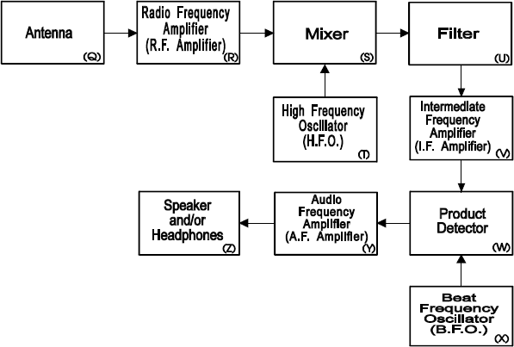

The receiver adjusts its gain by an *automatic gain control* (AGC) circuit. This circuit maintains a constant audio output for varying RF signal strengths by adjusting the gain of various stages in the receiver. Additionally, signal strength meter readings are derived from the AGC.

Single sideband is preferred over AM for long distance (DX) work as many of the problems associated with severe multipath and frequency dispersion are eliminated. The drawback of single sideband is that a replica of the removed carrier must by synthesized at the receiving station in order to recover the information.

### FM Receivers

The original message waveform is recovered from an FM signal by means of a *discriminator*. This frequency sensitive circuit outputs a signal corresponding directly to the instantaneous frequency of the received signal. For best receiver performance, the IF filter must be matched correctly to the bandwidth of the incoming signal. Within the IF stage, the *limiter* sets the signal to a fixed level immediately before the discriminator. The gain of the receiver stages is fixed; there is no AGC. A *squelch* circuit mutes the audio output when there is no signal, eliminating a constant loud rushing noise that would otherwise be present.

If more than one transmitter is operating at the same time on the same frequency, only the loudest transmission will be heard, this is called the capture effect.

*Figure 34 Frequency modulated receiver*

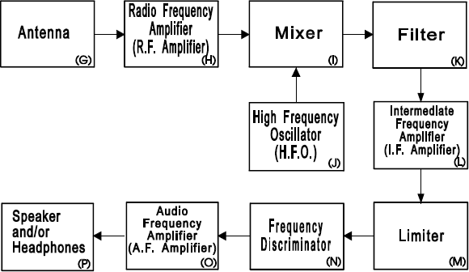

### Filters

Filters are usually installed between the AF amplifier and the rest of the demodulation circuitry of the receiver allowing unwanted frequencies to be filtered out of the audio output. These filters are typically 250 Hz, 500 Hz, 2.4 kHz, and 6 kHz. Depending on what signal is being received the filters need to be chosen carefully so that the received signal is not cut off and so that unwanted frequencies are not passed to the listener, making the received signal harder to hear.

For example, if receiving a CW transmission (bandwidth 150 Hz) the 250 Hz filter should be chosen, and if receiving SSB (bandwidth 3 kHz) the 2.4 kHz filter should be chosen.

## Transceivers

A transceiver is a package containing a transmitter and a receiver. Most modern stations use transceivers. A transceiver greatly simplifies the construction of a two-way station as many circuits are common to both a transmitter and receiver. When the unit goes into the transmit mode, the receiver is muted and disconnected from the antenna, but is not disconnected from the power source. Once the antenna has been connected to the transmitter, the unit begins transmitting.

## Repeaters

A repeater is a station setup to receive communications and retransmit them on a different frequency to extend the range of a transmitter. Repeaters can only be setup and maintained by an operator who has the Basic and Advanced qualifications.

A repeater is not allowed to autocratically retransmit signals received on frequencies below 29.5MHz unless the signals are received from a person qualified to transmit on those frequencies. This prevents operators with the Basic qualification from exceeding the frequencies allowed by their license.

# Interference And Suppression

## Introduction

Radio transmissions can cause interference with nearby electronic equipment. Such radio frequency interference (RFI) can render some equipment completely useless. The responsibilities for suppression of interference are dealt with in the regulations section. This section will deal with the causes and solutions of common RFI problems. Because the equipment most often interfered with belongs the amateur radio enthusiasts, it is important to be able to correct manufacturing inadequacies in today's consumer electronics. A brief discussion of filters will be followed by the types of interference and the application of filters to suppress them.

An amateur radio transmitter is deemed to be the cause of interference if the field strength it is generating at the point of interference is greater than 1.83 volts per meter. If the field strength is less than that, it is deemed to be insufficient shielding on the receiver. Broadcast transmitters are excluded from field strength requirements.

## Filters

Filters form the basis of most RF circuits. A filter is a frequency selective circuit which passes signals of certain frequencies while attenuating others. As filters are able to select desired frequencies from undesirable frequencies, they are fundamental to suppressing interference.

Typical measures of a filter are its cutoff frequency and its Q. The cutoff frequency is defined as the frequency at which a signal will be reduced to half the power of the maximum signal passed. The Q (or quality) of a filter is a measure of how sharp the filter is. High Q filters are those with a relatively narrow bandwidth, while low Q filters have a relatively wide bandwidth. A filter's bandwidth is the distance between cutoff points. The Q is, then, the ratio of the center frequency to the bandwidth of the filter.

### Low Pass Filters

A low pass filter passes low frequencies (including DC) but blocks high frequencies. A simple inductor has this property, although most filters are made from a combination of circuit elements. Low pass filters are used to remove excess harmonic energy from a signal at a transmitter's output. They can also be used on receivers to reduce an interfering signal which is above the received frequency. If RF signals are being picked up by long wires (ie. speaker or telephone wire) acting as antennas, the wire can be run through a ferrite bead to filter out the high frequency interference. Shortening the leads can also solve this issue. If inserting a low pass filter into a transmission line, the filters impedance should be about the same as the impedance of the transmission line.

### High Pass Filters

A high pass filter passes high frequencies but blocks low frequencies. A simple capacitor has this property, although most filters are more complicated. They are typically used on receivers and TVs to reduce interference from signals that are lower in frequency, typically to reduce or eliminate front end overload.

### Band Pass and Band Reject Filters

These filters can be used when only a certain frequency range is desired. The band pass filter can be used on a receiver to eliminate signals above and below the desired frequency. A band reject filter can be used to remove a specific interfering signal (i.e. a strong FM signal which is interfering with TV reception). Both of these types of filters can be assembled from low and high pass filters or be specifically built for the purpose if high Q is desired. As most interference problems with operation in the VHF amateur bands involve signals which are in the middle of most TV and radio bands, band pass and band reject filters are often the best solution.

## Types of Interference

### Front End Overload

Front end overload (receiver overload) is the entry, by brute force (exceptionally high signal strength), of a radio signal from a nearby transmitter into the receiver of a TV or home stereo. Because televisions are usually more susceptible to interference, most examples will involve the effects on TVs. The solutions, however, are equally applicable to radio receivers. Front end overload is typically indicated by a TV's complete loss of picture and sound when the transmitter is on regardless of what channel or frequency the transmitting or receiving device is tuned to. It is a common problem with amateur transmission on the 6 meter band as this band is right beside TV channel 2 (the amateur band was originally designated channel 1). Suppression of this type of interference involves reducing the interfering signal sufficiently to permit the receiver front end (TV or stereo) to tune it out.

This can be accomplished by moving the receiving and/or transmitting antenna(s), switching to cable TV (a common solution these days), or installing a high pass or band reject filter on the input of the TV. More than one method may be needed to completely solve the problem.

### Audio Rectification

Audio rectification is the demodulation (rectification) of an RF signal within the audio circuit of the receiver. It is characterized by the reception of the interfering radio signal along with the desired program by the receiver. Such interference is independent of the receiver tuning as it enters after the tuning circuit. It commonly occurs as a result of poor shielding of the receiver circuits and can be solved by adding shielding to the receiver or bypassing the RF that gets into the audio circuit with a capacitor before it is detected. Audio rectification can be reduced on the transmitter end by ensuring that there is a good ground connection.

### Harmonics

Harmonics are multiples of a transmitted frequency that are produced by exciting a non- linear circuit element (i.e. diodes, transistors). They are present in any signal which has a distorted sine wave, which are typically produced by over-driven radio stages. An example is over-modulation of a transmitter ("flat-topping"). Reducing the microphone gain in this instance will significantly reduce the harmonic output. Harmonics should be suspected if a transmitter on a lower frequency causes interference to a frequency which is a multiple of it. For example, if a transmitter at 29 MHz (10 m band) causes interference to a receiver at 87 MHz (TV channel 6), the probable cause is harmonics (3 x 29 = 87). Harmonic interference occurs at distinct frequencies.

*Table 3 Frequencies of broadcast television*

|  |  |  |  |  |  |  |  |  |  |  |  |
| --- | --- | --- | --- | --- | --- | --- | --- | --- | --- | --- | --- |
| Channel | 2 | 3 | 4 | 5 | 6 | 7 | 8 | 9 | 10 | 11 | 12 |
| Frequency (Mhz) | 54-60 | 60-66 | 66-72 | 76-82 | 82-88 | 174-180 | 180-186 | 186-192 | 192-204 | 204-210 | 210-216 |

Harmonics can be produced within transmitters and receivers or outside of both. Harmonics generated within a transmitter are required by law to be filtered out. This is accomplished with a low pass filter on the final output of the transmitter (normally installed internally by the manufacturer). Some older radios use an external circuit mounted between the transmitter and the antenna. Harmonics within a receiver generally cause cross-modulation (see section 5 *Cross-Modulation*). Harmonics can, however, also be generated by a bad connection between two metal surfaces (i.e. gutters, metal roofing, antennas). The joint can oxidize and form a poor-quality diode which, when excited by a RF field, produces harmonics. These can often be found by keying the transmitter and then moving suspect metal objects until the interference changes. Harmonics which are not exactly on the received frequency can be removed with a selective filter - a band reject, high pass or low pass filter. This will not work if any desired signal lies within the cut off region of the filter. Generally, harmonics should be suppressed at the source. All commercial transceivers are constructed to do this.

### Parasitic Oscillations

Parasitic oscillations are unwanted oscillations within the transmitter that can be heard above or below the transmitted frequency, there is no correlation between the operating frequency and the parasitic oscillating frequency. This is caused by portions of the transmitter circuitry oscillating when they are not intended to. Parasitic are suppressed by adding additional components to the circuit which suppress the undesired oscillation without affecting the primary function of the circuit.

### Cross-Modulation

Cross-modulation is the mixing of two frequencies within a receiver's front end (the first amplifier or mixer stage) to produce interference with a third (desired) frequency. For instance, if a commercial AM transmitter (strong) at 150 MHz mixed with an amateur signal (weak) at 52 MHz, it could produce interference to a FM broadcast signal at 98 MHz replicating the strong signal in the background of the 98MHz signal. This effect is caused by the rectification (or demodulation) of the strong commercial AM transmission modulating the received signal incite the receiver, depending on where the modulation is occurring, this effect may be heard no matter what frequency the receiver is tuned to. Cross-modulation should be suspected if there is interference only when both transmitters are operating. The solution is to remove one or both of the source signals from the passband of the receive using a high pass filter.

### Spurious Emissions

Poorly tuned or malfunctioning transmitters may emit RF energy on unintended frequencies, this is called spurious emissions. These emissions will show up on frequencies other than the one you are transmitting on when your radio is active. They can also be created if shielding inside the radio is missing or is not properly grounded allowing the frequencies inside the transmitter to radiate from within the device.

# Propagation And Antenna Systems

## Waves And Propagation

A basic feature of amateur radio is the transmission of signals from point to point without wires. Radio signals travel from the transmitter antenna to the receiver antenna in various ways depending on the frequency used. Some frequencies can use the ionosphere to bounce signals around the world, while other frequencies can be used only for local communication.

Radio waves are the bottom part of the spectrum of electromagnetic radiation, with infrared, light, ultraviolet, X-rays and cosmic rays at higher frequencies. Radio waves are further subdivided into different frequency ranges. MF (medium frequency) covers from 0.5 to 3.0 MHz, HF (high frequency, also called shortwave) covers from 3 to 30 MHz, VHF (very high frequency) covers from 30 to 300 MHz, and UHF (ultra high frequency) covers from 300 to 3,000 MHz. All electromagnetic radiation travels at the same speed, commonly referred to as the speed of light (c = 3 x 108 meters/second or equivalently 300,000 km/s).

Electromagnetic radiation consists of two waves traveling together (magnetic (H) and electric (E) waves) with the plane of the waves perpendicular to each other.

The polarization of a radio wave is determined by the direction of the electric field wave. Most antennas radiate waves that are polarized in the direction of the length of the metal radiating element. For example, metal whips such as those used on cars are vertically polarized, while most TV antennas are horizontally polarized. Polarization is important on VHF and higher, but not very important on HF communications because the many reflections that a sky-wave undergoes makes its polarization quite random with the polarization changing from moment to moment. Polarization can be caused by reflections, refractions, or passing though magnetic fields (Faraday rotation).

### Transmission propagation

Radio waves can travel in several different ways depending on their frequency. These modes of propagation are called ground-wave, line-of-sight, or sky-wave.

#### Ground-wave

Ground waves travel along the surface of the earth and depends on the surface conductivity, allowing the transmission to be heard by distant stations regardless of the curvature of the earth. This mode of propagation is most useful for transmissions in the MF band (300kHz to 3MHz), and is primarily used by AM transmission stations. The travel distance for ground waves can be up to 100km on land, or exceeding that over the ocean, but decreases as the transmitted frequency increases.

#### Line-of-sight (Direct waves)

Line-of-sight communication is the transmission of waves between 2 antennas that have little or no physical obstacles between them. Direct waves are the most important for communication on frequencies in the VHF and UHF bands above 50 MHz. The signal might be reflected off buildings and mountains to fill in some shadows, but usually communication is just line of sight. Frequencies above 50MHz are not reflected by the ionosphere and cannot make use of sky-wave propagation. However, variations in atmospheric density can bend the radio waves back down to the earth, referred to as tropospheric wave. Temperature inversions can create a situation where VHF transmissions get trapped between 2 density layers (tropospheric ducting) allowing them to travel up to 800km.

#### Sky-wave

Sky-wave (or ionospheric wave) propagation is the reflection of radio waves off of the ionosphere, allowing them to be directed around the curvature of the earth. Sky-waves are mainly used for long distance communication in the HF band (3MhZ to 30MHz) as these frequencies are best reflected by the ionosphere.

### The Sun and the Ionosphere.

The ionosphere is the upper region of the atmosphere, where the sun’s energy charges gas molecules. The degree of ionization varies with the intensity of the solar radiation, primarily in the Ultraviolet frequencies. The sun will also emit radio waves (solar flux) which can sometimes interfere with communication. A measure of this is the solar flux index which is a measure of the solar activity taken at a specific frequency.

Various cycles affect the amount of solar radiation, with the obvious ones being daily and yearly cycles. This means that ionization will be greatest around noon in the summer, and at minimum just before dawn in winter. In addition, the output of the sun varies over a longer period of approximately 11 years depending on sunspot activity. Greater solar activity generally results in better conditions for radio propagation by increasing ionization.

However, very intense activity in the form of geomagnetic storms, triggered by a solar flare, can completely disrupt the layers of the ionosphere and block communications. This can happen within minutes and communications can take hours to recover.

### Ionospheric Layers

The ionosphere is not a homogeneous region, but consists rather of distinct layers which have their individual effects on radio propagation, known as the D, E, and F layers. The layers of primary interest to radio amateurs are the E and F layers. The E layer, the lower of the two, is located at an altitude of approximately 110 Kilometers. It is in the denser region of the atmosphere where the ions formed by solar energy recombine quickly. This means the layer is densest at noon and dissipates quickly when the sun goes down. The F layer is higher and during the day separates into two layers, F1 (225 km) and F2 (320 km). It merges at night to form a single F layer at approximately 280 Kilometers. The layers are most ionized just after noon during the day and have fully combined and are least ionized just before dawn.

The different layers of the ionosphere can reflect radio waves back down to the earth, which in turn can reflect the signal back up again. In this fashion, a signal can "hop" around the world. The bigger the "hop" the better, because each the signal loses energy with each “hop”. Using higher layers, the radio wave "hops" farther, with the F2 layer allowing single hops of up to 4500 km and the E layer only allowing hops of 2200 km. Lower angle radiation will go farther before it reflects off the ionosphere. To achieve the greatest distance communication (DX) choose a frequency that will reflect off the highest layer possible and use the lowest angle radiation possible. The distance covered in one "hop" is the skip distance. For destinations beyond the maximum skip distance, the signal must make multiple hops (multi-hop propagation).

*Figure 35 Ionosphere*

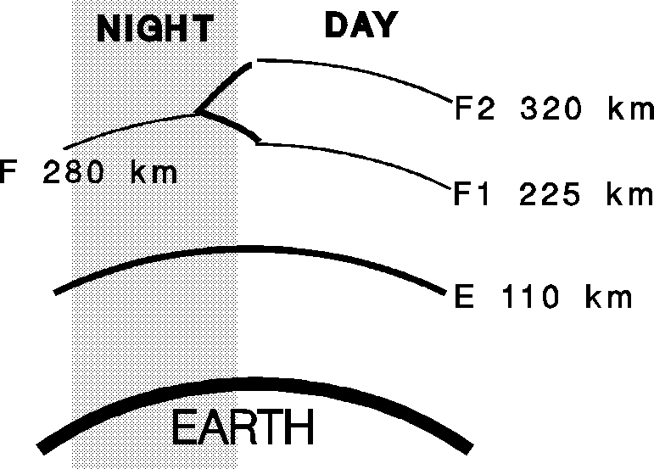

### Absorption

In addition to reflecting radio waves, the ionosphere can also absorb them. This absorption is greater with lower frequencies and denser ionization. The D layer, which only exists during the day, will absorb almost all signals with a frequency lower than 4 MHz (i.e. the 80 and 160 m bands). Short range communication is still possible using higher angle radiation, which is less affected (it travels a shorter distance through the atmosphere). The signal can then reflect off the E layer to the receiver. The bottom layers (D and E) are responsible for the effect where one can hear only local AM radio stations during the day with distant signals better heard at night.

### Attenuation

The attenuation of a signal by the ionosphere is higher at lower frequencies. Higher frequencies should be used for greater distance coverage. However, if the frequency is too high, the signal will pass directly into space and not reflect back to earth. While this is perfect for satellite communications, it is not suitable for HF DX. When trying to work DX on HF, try to use the highest frequency that will still reflect off the ionosphere.

The highest allowable frequency varies with solar activity and time of day. This frequency is referred to as the maximum usable frequency (MUF) or the critical frequency, with frequencies higher than that passing through the ionosphere. This can be calculated by various formulas if given the current solar indices. In the peak of the solar cycle, it can often be over 30 MHz (on rare occasions up to 50 MHz) and at other times (i.e. during the night) it can drop below 10 MHz. The best frequency for long range communication is usually slightly below the maximum useable frequency. To find out if a frequency is useable in a location you are trying to contact listen for signals from that location such as an amateur beacon station or foreign broadcast on a nearby frequency.

At the low end of the frequency spectrum, daytime absorption in the D layer limits the range possible. In addition, atmospheric noise is greater and limits the lowest usable frequency (LUF). Noise and absorption decrease at night, lowering the LUF at the same time the MUF is lowered by the decrease in solar excitation of the ionosphere. This usually means that by picking the right frequency, long distance communication is possible at any time.

### Fading

Radio waves can travel over different paths from the transmitter to the receiver. If the path length varies by a multiple of half of a wavelength of the signal, the two (or more) parts can partially or completely cancel each other. This causes fading of the received signal and is called multipath. Various phenomena can cause this. Aircraft, mountains and ionospheric layers can reflect part of a signal, while another part takes a more direct path. Fading can also occur when the signal passes through the polar regions. This is called polar flutter and is caused by a different phenomenon. The ionosphere is much more disorganized in the polar regions because of the interaction of solar energy with the geomagnetic field. The same phenomenon that causes aurora borealis can cause the wavering of signals on polar paths. Fading in wider bandwidth signals is more pronounced than fading in narrow bandwidth ones.

### Other Atmospheric Effects

Radio waves reflecting off of the atmosphere can be scattered, causing them to enter into the skip zone, with a low signal strength. These signals are often distorted and have a wavering sound as they can enter the skip zone through several different paths (ie, off of several ionosphere layers). This effect occurs mostly when the transmission frequency is above the MUF. There are several scatter modes including side scatter, back scatter, and forward scatter.

Sporadic E skip is a seasonal occurrence that usually happens during the summer. A small region of the E layer becomes more highly charged than usual, most notably extending the transmission distance in the 6 meter band and permitting the reflection of signals as high in frequency as 220 MHz. This highly charged region soon dissipates, and as a result, sporadic E skip will only occur from a few minutes to a few hours.

An even more exotic mode of communication involves bouncing signals off the ionized trails of meteors. Meteor scatter communications may last only a few seconds, so it is feasible only where large numbers of meteors are entering the atmosphere (i.e. during the Perseid meteor shower in August). Meteor scatter is most effective on the 6 meter band or in the 30MHz to 100MHz range.

### Skip Zone

The area between the limit of maximum range by direct wave or ground wave, and the minimum skip distance by sky-wave is the skip zone. Usually you should be concerned with the maximum possible range. But there are instances when operating close to the Minimum Useable Frequency (MUF), where you can talk to people thousands of kilometers away, but be unable to talk to someone only 500 kilometers away. This phenomenon is known as the skip zone. This occurs because the ionosphere can better reflect signals that are at a shallow angle (like light off a water surface). Those waves approach at a steeper angle, pass directly through, and are lost into space. The critical angle varies with the degree of ionization and generally results in larger skip zones at night.

*Figure 36 Skip Zone*

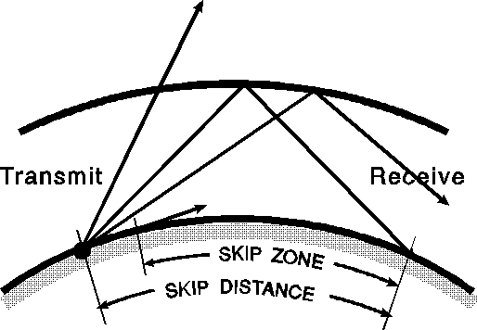

## Antennas

### General Description

The antenna is the part of the radio station that radiates the radio frequency (RF) energy into space. These generally consists of conductors arranged so that they direct energy in a desired direction. As antennas involve resonant components, the lower frequency antennas are generally larger, while the VHF and higher frequency antennas can be quite compact.

#### Antenna Impedance

An antenna represents a load to the transmitter that may have both a reactive and resistive component. For maximum transfer of power this impedance must be matched to the transmission line, and it in turn must be matched to the transmitter output. When an antenna is resonant, it has only a resistive component. If an antenna is too short (i.e. it is resonant at a higher frequency), it will have a capacitive reactance component. If it is too long it will have an inductive reactance. This is usually corrected by adding to or subtracting from the antenna length, but if the antenna size needs to remain fixed, it can be compensated for by adding a reactance of the opposite sign (inductive reactance is positive, capacitive reactance is negative). This is usually done by using a matching network or antenna tuner (i.e. transmatch).

#### Voltage Standing Wave Ratio (SWR)

When there is a mismatch of impedance between components of an antenna system (either at the antenna or the transmitter) some of the power will be reflected at the mismatched joint. This energy travels back down the line and causes a standing wave. This condition is usually measured with a SWR (Standing Wave Ratio) bridge. When the system has been matched perfectly (i.e. a 50 ohm line into a 50 ohm antenna) the SWR will be 1 to 1. Most radios will work perfectly with SWRs under

1.5 to 1. Many tube type transmitters can easily deal with SWRs as high as 4 to 1. The SWR bridge is a good indicator of antenna health, because a bad connection or broken conductor will usually cause a high SWR. The reflected power from a damaged antenna can cause transmitter damage by overheating the output (final) transistor(s) or, if low enough, just reduce the radiated power. Either way, it is a good idea to monitor the SWR bridge.

### Resonant frequency

The resonant frequency of an antenna is dependent on its length. As the antenna is made longer its resonant frequency decreases and as it is made shorter its resonant frequency increases. When an antenna is too short for a desired frequency it has increased capacitive reactance and when it is too long it has increased inductive reactance.

### Dipoles

The most common type of antenna is the dipole. It is an antenna with two parts or poles. It is usually a half wave in overall length and is fed in the middle. One pole of the antenna is connected to one side of the transmission line and the other is connected to the remaining side, either directly or through a phasing line. As the wavelength for a given frequency is the speed of light divided by the frequency, one can calculate the desired length of the antenna for any desired operating frequency. For a simple half-wave dipole the length would simply be half the calculated wavelength.

Rearranging the equation to solve for wavelength (λ):

where:

When making a dipole for HF frequencies, one usually has to reduce the length by 2 percent to account for capacitive effects at the ends. This is best done after installation because various factors (i.e. as height from ground and other nearby conducting surfaces, can affect it). The feedpoint impedance of a half-wave dipole installed about one wavelength or higher above ground (i.e. in "free space") is 73 ohms. When the ends are lowered (i.e. into an inverted V) the impedance drops to around 50 ohms. The ends of the antenna should be insulated as they are high voltage, low current points. The connections of the transmission line to the antenna should be soldered as the center of the dipole is a high current, low voltage point. The radiation pattern of a half wave dipole in free space has a minimum off the ends of the antenna and a maximum perpendicular to it, although this pattern degrades considerably when the dipole is brought closer to the ground.

A modified version of the simple dipole is a folded dipole (see Figure 37). In its most common form, it has two half-wave conductors joined at the ends. One conductor is broken and fed in the middle. If the conductor diameters are the same, the feed point impedance will be 4 times that of a standard dipole, or 300 ohms. A similar dipole with three instead of two conductors will have an impedance increase of 9 times. Folded dipoles will have a higher bandwidth than a standard dipole.

*Figure 37 Dipole*

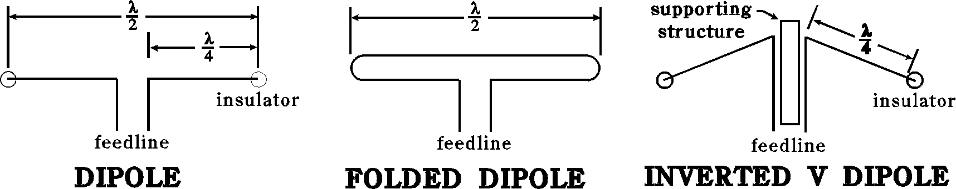

Dipole antennas will radiate energy in a doughnut shape around the antenna, Figure 38 is a cross sectional view of this pattern with the antenna on the vertical axis, forming a figure eight in this view. If the antenna was orientated so that its ends were pointed north/South it would radiate power in the East/West direction and none North/South. The dipole has a gain of 2.1dB over an isotropic radiator, or 2.1dBi with the “i” standing for isotropic.

*Figure 38 Dipole radiation pattern*

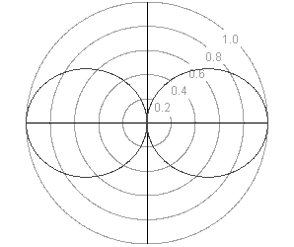

### Vertical Antennas

The simplest vertical antenna is the Marconi. This is a quarter wave radiator above a ground plane. Over a perfect ground it has a feedpoint impedance of 36 ohms, however with real grounds the impedance is usually between 50 and 75 ohms. This makes it a good match for 50 ohm coax cable, with the shield going to ground. The Marconi is a popular choice for mobile communications because it is the smallest antenna with reasonable efficiency. It can be thought of as half of a dipole with the other half appearing as a virtual image in the ground. A longer antenna can produce even lower radiation angles. However, the problems with longer antennas is that they can become too large at to conduct lower frequencies easily. A length often used at VHF frequencies is 5/8 of a wavelength as it provides gain over a 1/ 4 wave antenna. This length has a higher feed impedance and requires a matching network for most transmission lines but has a lower radiation angle.

Vertical antennas need a good, highly conductive ground. If the natural ground is poor, quarter wave radials can be laid out from the base of the vertical to form a virtual ground, with increasing feedpoint impedance as the radials are changed from horizontal to downward sloping. Vertical antennas provide an omnidirectional pattern in the horizontal plane, so they receive and transmit equally well in all directions. Vertical antennas are often used by DX operators as they produce low angle radiation, which is best for long distances.

Loading coils (series inductors) are sometimes added to vertical antennas to cancel out capacitive reactance and allow shorter antennas to be used.

*Figure 39 Marconi*

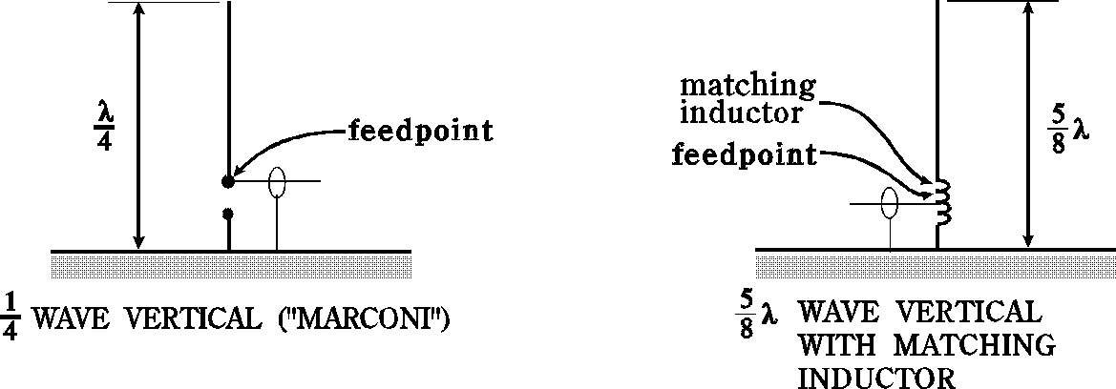

### Yagi antennas

Basic elements (either vertical or horizontal) can be combined to form arrays to improve signal transmission or reception in specific directions. The most common form of array is the Yagi-Uda parasitic array (commonly referred to as a Yagi array or beam). It consists of a driven element, which is either a simple or folded dipole, and a series of parasitic elements arranged in a plane supported by the boom (see figure 6 below). The elements are called parasitic because they are not directly driven by the transmitter, but rather absorb energy from the driven element and re-radiate it. Usually a Yagi will have one reflector behind and one or more directors in front of the driven element with 1/5th of a wavelength between each. The reflector will be slightly longer than the driven elements and the directors will be slightly shorter. In an analogy with a flashlight, the driven element can be thought of as the light bulb, the reflector as the reflector and the directors as the lens. The transmitted RF energy is then focused in the forward direction with more directors focusing the beam. In order to rotate the beam, the elements are attached to a boom and in turn to a mast that is connected to a motor (rotator).

The antenna can be optimized by adjusting the length of the elements and the distance between the elements.

*Figure 40 Yagi-Uda parasitic array*

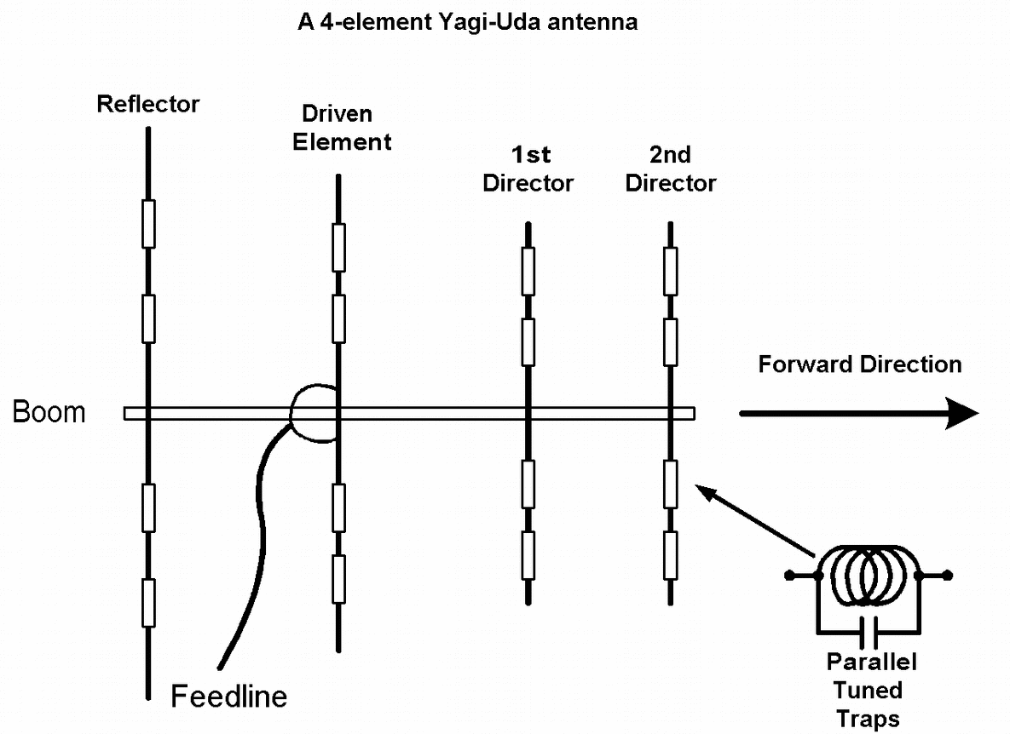

*Figure 41 Yagi-Uda parasitic array radiation pattern*

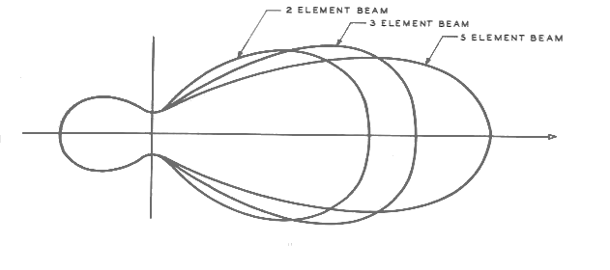

A dipole or a Yagi antenna can be designed to work on more than one band. For HF, the 10, 15 and 20 meter bands are commonly combined in one antenna. This is accomplished by adding a trap built from a parallel inductor and capacitor to the elements of the antenna to increase their electrical length for specific frequencies. However, traps will cause the antenna to radiate harmonics, which may be undesirable.

Stacking 2 Yagi antennas on top of each other will double the gain. Increasing the diameters of the elements will increase the antennas bandwidth.

### Quads and Loops

A cubical quad antenna is a directional antenna constructed of two or more parallel four sided wire loops, each with a length of approximately one wavelength long. A variant of this antenna is the delta loop using triangles instead of squares. Similar to the yagi antenna there is a driven element and a parasitic element acting as a reflector. Two element quad antennas have a similar performance to a 3 element yagi antenna. The feed point for the antenna can be located at the bottom giving it a horizontal polarization or on the side giving it a vertical polarization. The impedance of the quad loop antenna is approximately 100 ohms.

The performance of both cubical quads and yagi antennas can also be measured in terms of the ratio of the power radiated in the favoured direction vs the power radiated in the opposite direction. This parameter is called the "front-to-back ratio". A high front-to-back ratio is useful when trying to hear a weak signal from one direction while a stronger signal is coming from the opposite direction.

*Figure 42 Cubical Quad Antenna*

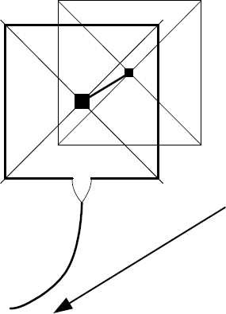

### Antenna Measurements

Most antenna measurements are given in decibels (dB). Decibels are a logarithmic scale where 3 dB corresponds to 2 times the power, 6 dB 4 times and 10 dB 10 times. Important figures for a beam antenna are forward gain, front-to-side ratio and front-to-back ratio.

Forward gain is often given relative to a simple dipole. For example, if an antenna is said to have a gain of 10 dB (over a dipole), then the radiated energy would be 10 times stronger in its maximum direction than a simple dipole. Another comparison standard is the isotropic antenna or point source with a spherical radiation pattern. This is a hypothetical antenna that would radiate equally well in all directions in all planes (unlike a vertical antenna which radiates equally well only in the horizontal plane). A dipole has 2.3 dB gain over an isotropic radiator. A front-to-back ratio of 20 dB would mean that the energy off the back of the beam would be one one-hundredth that of the front. Similar relationships hold for front- to-side ratio.

Another antenna measurement is the bandwidth or range of frequencies which the antenna can be used for. High gain antennas usually have a narrower bandwidth than low gain antennas. Some antennas can only cover a small portion of the band they are used in while others can cover several bands. Still other antennas are designed to operate on a range of specific bands but not in between these bands. A simple antenna, which can be used on two bands, is a half wave dipole for 40 m. It can also be used on 15 m.

### Dummy Loads

One piece of equipment that is not really an antenna but is related to one is a dummy load. A dummy load is a pure resistance that is put in place of an antenna to test a transmitter without radiating a signal. Commonly referred to as a termination, when placed at the end of any length of coax it will make the feedline look like an infinite length, provided that the load is matched in impedance to the line. Most transmitters require an output impedance of 50 ohms, so a dummy load is simply a high power 50 ohm non-inductive resistor. The resistor can be submerged in oil to improve its power capacity. A dummy load can be used when locating interference sources and should be placed on the transmitter output when the transmitter is not in use. This will prevent the transmission of a signal or damage to the transmitter if the radio is accidentally keyed.

### Antenna Orientation

When orientating a directional antenna, it is helpful to have an azimuthal map, which is a map centered on a particular location that is used to determine the shortest path between 2 points on the earths surface. Some times when listening for stations in a particular location the reception may be best (depending on atmospheric conditions) if pointing in the opposite direction (180 degrees) from the shortest path, this is also known as the “long-path” direction.

*Figure 43 Azimuthal map centered in the Eastern USA*

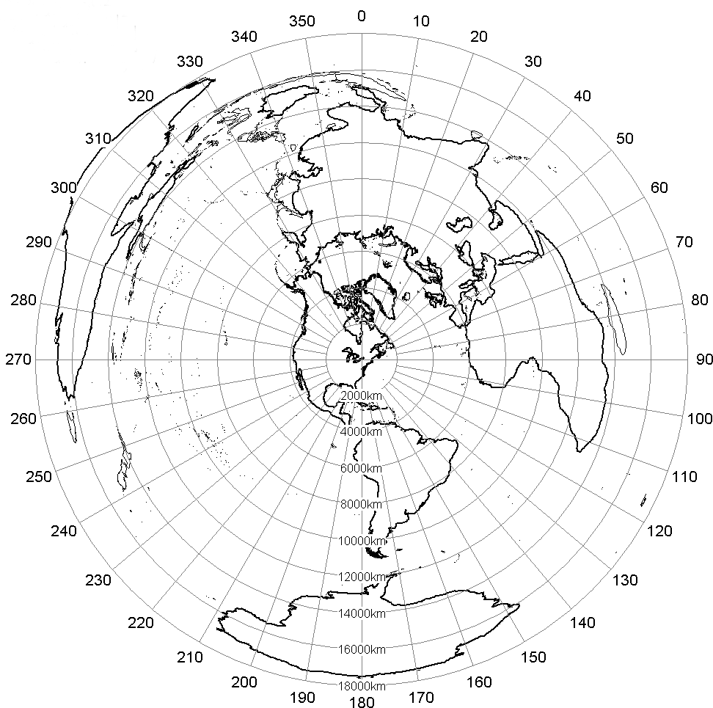

### Antenna Structures

Antennas for amateur radio use may for increased performance and long-distance communication. Before the structure is constructed any community, concerns must be address as well as consulting the land-use authority to determine if the structure is permitted and must accept any consequences from not doing so. There is no requirement to receive Innovation, Science and Economic Development Canada approval. For the purpose of environmental filing, amateur stations are considered to be Type 2 (non-site specific).

## TRANSMISSION LINES

Transmission lines (feedlines) are the link between the transceiver and the antenna. There are many different types, but the two types that are most popular on frequencies under 1 GHz are parallel conductor lines, and coaxial cable. Parallel conductor lines consist of two parallel conductors held at a fixed distance by insulators. This type of transmission line is balanced. Coaxial cable is the other major type of line and consists of two concentric conductors, and it is an unbalanced transmission line.

Transmission line loss will reduce the transmitter power that radiates out the antenna. These losses increase with higher SWR and higher frequency. As most line loss occurs in the insulators supporting the conductors, lines such as ladder line will have lower loss than most coax.

An important characteristic of a transmission line is its impedance. It is measured in ohms and can range from 30 ohms for high power coax to 600 - 1000 ohms for wide spaced ladder line. This impedance is equal to the pure resistance than has to be placed at the end of the line to absorb all of the power transmitted. If this impedance is placed on the end of the transmission line it will appear as an infinetly long transmission line. While the units of measure are ohms, impedance can’t be measured by putting the coaxial line in an ohmmeter. The characteristic impedance is not dependent on the length of the line but rather on its physical arrangement of conductors. If the feedline impedance does not match the impedance of the transmitter or the antenna standing waves will be produced.

### Parallel conductor

Parallel conductor, also known as ladder line or open wire, is made of 2 parallel conductors separated by an insulator. Ladder line is inexpensive and had very low loss at HF frequencies. The disadvantage of ladder line is that it must be kept away from other conductors, and cannot be buried or strapped directly to a tower. Also, as the frequency increases and the line spacing becomes a significant fraction of the wavelength, the line will radiate some power. Because it is a balanced line, it can feed a dipole directly without a balun at the antenna. However, most transceivers now have a 50 ohm unbalanced output and will require a balun transformer at the transceiver end. The impedance of these lines varies according to the spacing and diameter of the conductors. TV twin lead has an impedance of 300 ohms, while commercial ladder line usually has an impedance of 450 or 600 ohms. Open-wire feedlines are well suited for high SWR transmission. The impedance of the line is determined by the diameter of the conductors, the dielectric between them, and the spacing between the centers of the conductors.

*Figure 44 Ladder Line*

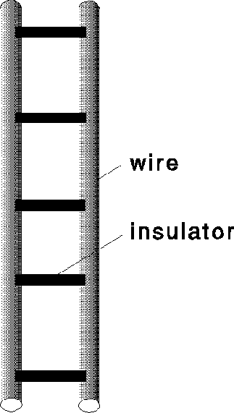

### Coaxial Cable

Coaxial cable consists of coaxial conductors with dielectric insulation in the gap. The inner conductor carries the signal and the outer conductor is usually at ground potential. As the outer conductor completely shields the signal on the inner conductor, coaxial line can be buried or run close to metal objects with no harmful effects. Coaxial cables come in various sizes, the smaller sizes are for short distances and low power while the larger sizes have greater power handling capability as well as lower loss. The ratio of the conductor sizes and the distance between them determines the feedline impedance and a larger diameter cable does not mean that the impedance of the line is different. Most amateurs use 50 ohm coaxial while cable TV mainly uses 75 ohm coax. The dielectric (insulator) used is the main source of power loss. Most coax uses solid polyethylene, while some types use foamed polyethylene. The foam version has lower loss, while the solid insulator is more rugged.

Hardline has extremely low loss because it has a solid outer conductor (rather than a wire braid), and the inner conductor supported on either an insulating spiral or beads so that most of the insulation is air. This type of feedline is harder to work with because it can’t be bent very sharply, and the connectors for it are very expensive.

*Figure 45 Coax cable*

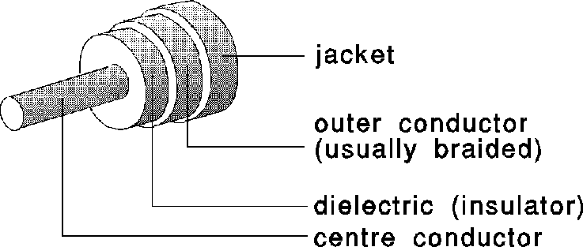

### Baluns

Baluns are devices that convert from a balanced to an unbalanced line. When a balanced antenna (such as a dipole) is fed directly with coax, the antenna currents (which are inherently balanced) will run on the outside of the coax to balance the coax cable currents, which are inherently unbalanced. This feedline current leads to RF radiation by the line and the antenna. This can distort the antenna pattern. Also, the RF can travel back down the shielding to the station and cause metal surfaces to become live with RF. RF shocks, while not fatal, are unpleasant and should be avoided. To avoid shocks use a balun when connecting balanced to unbalanced (and vice versa). A balun transformer is a device that may be found on the back of a TV, connecting the antenna terminals to your cable television coax. This device is converts from balanced to unbalanced, in addition to transforming the impedance from 75 to 300 ohms.

## Antenna Safety

Antennas and antenna towers pose several safety hazards including lightning strikes and falling during maintenance.

When not in use all of your antenna cables and any other cabling running from the tower (ie. Rotator control wires) should be connected to ground to prevent damage to the building and equipment.

While installing or doing maintenance on antennas and towers equipment that meets your provincial safety standards should be worn. A safety belt should be worn when climbing towers to prevent you from accidentally falling and if you are working below someone on a tower, a hardhat should be worn.

Antenna structures should be mounted high enough off the ground so that no one on the ground can accidentally come in contact with then as they can have high voltages on them or cause RF burns if they are touched while transmitting. If mounted in a house, the antennas should be mounted as far from living spaces to reduce RF exposure. High gain, directional antennas should be mounted higher than surrounding structures so that they don't direct energy into surrounding buildings. When ever working on an antenna the station transmitters should be turned off and the feedlines disconnected to prevent accidentally energizing the structure.

Radiated RF energy can be harmful to the human body. According to Health Canada Saftey Code 6 (defining RF exposure limits for the human body), the most harmful frequencies are in the 30MHz to 300MHz range where it is most easily absorbed. The RF energy will heat the body tissues, with the eyes being the most sensitive. The maximum exposure levels of Rf fields in the 10 to 300MHz band is 28 VRMS/meter (E-field) and for the 30 to 300MHz band 0.073 ARMS/meter (H-field), with the permissible levels increasing below 10MHz and above 300MHz.

Whenever working on RF antennas or equipment make sure that it is locked out so that there is no chance of being energized. When operating hand held transmitters, Although there is no official power output limit (removed in 1999), no matter how small the antenna should be situated as far from the head and eyes as possibly to reduce the absorbed energy.

# Operations And Procedures

## Introduction

This section contains information about equipment you may encounter while operating the radio and some basic protocol while on the radio.

## Basic Operation and Communication

### Making Contacts

Before transmitting on a frequency to make a contact you should first listen on that frequency to determine if someone is using that frequency already. If they are, change your frequency to avoid transmitting over top of someone else.

If you are looking for someone to talk to over the radio you will call CQ (Seek you). This is done by repeating “CQ” three times followed by “this is” and your call sign followed again by three more “CQ”s.

CQ CQ CQ this is VE7UBC CQ CQ CQ

Answering another stations CQ is done by saying the other stations call sign followed by “this is” and your call sign.

VE7ACS this is VE7UBC

If you know the call sign of a station you are trying to get a hold of say their call sign then identify your own station with your call sign.

VE7ACS, VE7UBC

If conditions change during your contact and increased interference is heard, move your communication to a different frequency without interference.

### Making contacting with Morse Code

If calling CQ using Morse code, the “this is” is replaced by “DE” (from).

CQ CQ CQ DE VE7UBC CQ CQ CQ

If the CQ is being answered using Morse code, the “this is” is replaced by “DE” (from).

VE7ASC DE VE7UBC

When finishing a communication with another station end the final sentence with “K” indicating to listening.

* K = any station transmits
* DX = distant station
* 73 = Best regards

Morse code CQ should be transmitted at any speed that can reliably be received by the transmitting station.

Morse code transmissions should be space 150 to 500Hz apart to reduce interference from adjacent conversations.

### Transmit Power and Signal Reports

If your transmission is coming in strong at the receiving station you should decrease your transmit power. This allows you to use less energy as well as reducing how far your transmission propagates, allowing a distant station to use the same frequency.

When talking to another station you may be interested in how well the other station is receiving your transmission and the transmitting station may be interested in how their signal is being received. Signal reports cover three aspects of signal ineligibility, Readability, Signal strength, and Tone or RST. Readability quantify how easy it is to understand the information being transmitted and is rated out of 5 with 1 being unreadable and 5 being perfectly readable. Signal strength is a measure of how strong the signal is at the receiving station and is rated out of 9 with 1 being very weak, 6 being good, and 9 being very strong. Tone is used for Morse code and digital transmissions and is rated out of 9 with 1 being a poorly shaped signal and 9 being perfect tone with no traces of ripple or modulation.

Radio receivers measure the relative strength of received signals using a S meter. Each increment on a S meter (S8 to S9) corresponds to an increase in received power by a factor of approximately 4. After S9 the signal strength is reported in dB above S9 (ie. “Your signal report is 5 9 plus 20dB”).

### Simplex and Duplex Communication

Simplex transmission is the use of one frequency for both transmission and reception, necessitating each party participating in a contact take turns talking.

Duplex communication is the use of two frequencies for communication, one for transmission and one for reception.

### Upper and Lower Sideband Transmission

An informal agreement is used by amateur operators using phone (voice) communication as to what sideband (upper or lower) is to be used in different frequency ranges. The convention is that below 10Mhz lower sideband is used and above 10Mhz upper sideband is used.

### Communication Nets

Nets are the RF equivalent of an online chat room with multiple stations using the same frequency in a structured and organized manner. The net is controlled by a net control operator whose job is to bring attention to each station participating in the net allowing them to speak in turn. To maintain order, if it is not your turn to speak and the operator has not expressly said your call sign, do not transmit.

If a frequency that is regularly used for a net is in use prior to a net starting the stations transmitting on that frequency can be asked to move (although they do not have to) or the net can be moved 3 to 5 khz away from the regular net frequency.

## Emergency Operation

For the purpose of emergency preparedness, it is a good idea to have a way to power your station without the use of a AC power source (ie. A battery) and for hand held radios it is a good idea to have several sets of batteries.

An antenna generally considered a good choice for emergency use is a portable Yagi, providing good gain and directionality to locate a transmitting station.

## Repeaters

Repeaters receive a radio signal on one frequency and retransmit (repeat) it on another, allowing a transmitter to reach further or access to more advantageous transmission locations. The difference between the receive frequency and the transmit frequency is usually around 600hz to avoid interference. Some repeaters have a 'password' in the form of a sub-audible CTCSS (or PL) tone that is required to be transmitted with the signal to be repeated before the repeater will retransmit the signal.

Some repeaters are known as autopatches and are tied into a phone line allowing an amateur operator to make phone calls using their radio. This is different than passing third party traffic in that it is an amateur radio operator making the call not an unlicensed individual.

Contacting someone who’s call sign is known over a repeater is the same as making a call directly from your transmitter, say their call sign then identify your own station with your call sign

Communication using repeaters should be kept short and only used as necessary as the repeaters are sometimes setup for emergency use and long transmissions may keep others from using the repeater for emergencies. To intentionally keep transmissions short, some repeaters will have a time-out timer that limits how long someone can make an uninterrupted transmission.

Pauses between transmissions on a repeater are encouraged to allow you to listen for other people wanting to use the repeater. If you need to break into a conversation already in progress, say your callsign during a break in transmissions and wait for the people involved in the conversation to acknowledge you.

If you find that you are operating your transmitter on the same frequency as a repeater, it is courteous to change your transmission frequency to avoid interference as it is difficult to change the frequency of a repeater.

## Band Plan

The 2 meter band is divided up into different segments allocated to different activities. A brief chart giving examples for British Columbia is given below, but keep in mind that exact frequencies within these band segments may differ by region (for example, Ontario uses 15kHz spacing, not 20kHz).

*Table 4 Band plan*

|  |  |
| --- | --- |
| Frequency | Mode |
| 144.000 - 144.100 | CW (Morse code) |
| 144.100 - 144.300 | USB |
| 144.300 - 144.500 | Mode L satellite uplinks (SSB and CW) |
| 144.510 - 144.890 | Repeater inputs (don't transmit simplex here!) |
| 144.910 - 145.090 | Packet radio every 20 kHz |
| 145.110 - 145.490 | Repeater outputs every 20 kHz (-600 offsets) |
| 145.510 - 145.690 | Packet radio duplex digipeater inputs |
| 145.710 - 145.790 | Simplex every 20 kHz |
| 145.800 - 146.000 | Mode B satellite downlinks (don't transmit!) |
| 146.020 - 146.400 | Repeater inputs (don't transmit simplex here) |
| 146.420 - 146.600 | Simplex every 20kHz (146.520 FM simplex calling frequency) |
| 146.620 - 147.000 | Repeater outputs every 20 kHz (-600 offset) |
| 147.020 - 147.380 | Repeater outputs every 20 kHz (+600 offset) |
| 147.400 - 147.580 | Simplex every 20 kHz |
| 147.600 - 147.980 | Repeater inputs (don't transmit simplex here) |

Similar plans exist for all other amateur frequencies. You should talk to someone who uses the other bands and is familiar with them, before transmitting on those bands.

## Standard Phonetic Alphabet

If you are transmitting your callsign using voice transmission the standard phonetic alphabet should be used to make your callsign easier to understand under poor reception conditions. Avoid using words outside the standard alphabet as this can be confusing to the receiving operator as the words in the standard alphabet are chosen to sound distinct from each other and other random words may sound similar to others.

*Table 5 Phonetic alphabet*

|  |  |
| --- | --- |
| **A** – **A**lpha | **N** – **N**ovember |
| **B** – **B**ravo | **O** – Oscar |
| **C** – **C**harlie | **P** – Papa |
| **D** – **D**elta | **Q** – Quebec |
| **E** – **E**cho | **R** – Romeo |
| **F** – **F**oxtrot | **S** – Sierra |
| **G** – **G**olf | **T** – Tango |
| **H** – **H**otel | **U** – Uniform |
| **I** – **I**ndia | **V** – Victor |
| **J** – **J**uliet | **W** – Whiskey |
| **K** – **K**ilo | **X** – X-ray |
| **L** – **L**ima | **Y** – Yankee |
| **M** – **M**ike | **Z** – Zulu |

Good luck on the exam!

1. With the exemption of public broadcasters, you may tell others what you hear or see on CBC or other public radio stations.